**ABSTRACT**

Pneumonia is form of a respiratory infection that affects the lungs. It killed over 16% of people, most of them were children under the age of five in every year. **According to research, 11 million children under the age of five will have the disease by the year 2030.** Human lungs are made up of tiny sacs called alveoli that normally hold air in normal, healthy people, but in the case of pneumonia, these alveoli become filled with fluid or pus. That’s why getting a chest X-ray (CXR) is a key step in detecting and treating these respiratory diseases. The chest X-ray is a crucial tool in the treatment of pneumonia, and it influences many of the doctor's decisions. **The objective of this project was to develop an automated pneumonia detection system using medical imaging techniques.** In this study, convolutional neural network was used to diagnose pneumonia on a chest X-ray. This **strategy was chosen since the most common radiography technique had flaws.** Effective classification of chest X-rays into pneumonia and no pneumonia X-rays is shown in this work. **Chest X-Ray Images (Pneumonia) dataset from Kaggle was used for the experimentation.** In order to solve the issue, I attempted to discover any foggy/cloudy patterns in the X-ray to evaluate whether a chest X-ray indicated pneumonia or a normal state. **The project involves collecting a large dataset of labelled images, training a CNN model using various algorithms, and evaluating its performance through testing. Here, model achieved 94% of accuracy using CNN and determined accuracy using confusion matrix.**

**CONTENTS**

**1: INTRODUCTION**

1.1 Introduction to Classification

1.2 Convolution Neural Network

1.2.1 CNN Layers

1.4 Need of CNN

1.5 Challenges

1.6 Evaluation Metrics

1.7 Classification Metrics

1.7 Objectives

1.8 Dataset description

1.8.1 Classes in Dataset

**2: LITERATURE REVIEW**

2.1 Literature survey

**3: PROPOSED METHODOLOGY**

3.1 Chest X-Ray Dataset

3.2 Data Preprocessing

3.3 Splitting Data

3.4 Proposed method (CNN)

3.5 Data Visualization

3.6 Classification Output

**4: RESULT AND DISCUSSION**

4.1 Snapshots

**5: CONCLUSION**

**REFERENCES**

**1.INTRODUCTION**

Pneumonia is form of a respiratory infection that affects the lungs. It affects 450 million people worldwide or 7.5% of the population, and it kills 4 million people annually. Among that most of them were children under the age of five. Pneumonia may infect from bacteria, viruses, or other micro-organisms. Pneumonia is regarded as one of the deadliest infections. All ages are susceptible to pneumonia, although some populations are more at risk than others, including small children, elderly adults, and people with compromised immune systems or underlying medical disorders. When an infected individual coughs or sneezes, it can be spread through respiratory droplets, or by touching infected surfaces and then contacting your face.

The World Health Organization (WHO) reported that pneumonia is contagious disease would spread throughout the world. According to the WHO, pneumonia is the main cause of child malnutrition worldwide. The majority of children that have pneumonia sickness reside in South Asian nations including India, Pakistan, Bangladesh, Sri Lanka, and Indonesia, among others. Only India experienced 158,176 deaths in 2016, pneumonia causes infant deaths.

Human lungs are made up of tiny sacs called alveoli that normally hold air in normal healthy people, but in the case of pneumonia, these alveoli become filled with fluid or pus**, making difficult to breathe**. That’s why getting a chest X-ray (CXR) is a key step in detecting and treating these respiratory diseases. The radiograph is currently the most reliable Pneumonia detection approach that doctors will use. However, some studies claim that variations in radiologist interpretation of chest radiographs are common. This shortcoming of human observation has sufficiently motivated technology to make an impact in this area where machines will distinguish between a normal chest X-ray and an abnormal one.

**The objective of this project was to develop an automated pneumonia detection system using medical imaging techniques**. Here, project describes the detail of methodology, data preprocessing, model architecture, training process, evaluation metrics, and results of our pneumonia detection project. Furthermore, discuss the challenges encountered during the project, propose potential improvements, and emphasize the significance of this technology in enhancing healthcare delivery and addressing public health challenges related to pneumonia.

**1.1 Introduction to Classification**

Deep learning and machine learning techniques are becoming more and more popular when it comes to analysing chest X-rays because of their low cost and ease of usage. So here I use those methods to build this model. Machine learning has made significant strides toward improving disease diagnosis in the medical field.

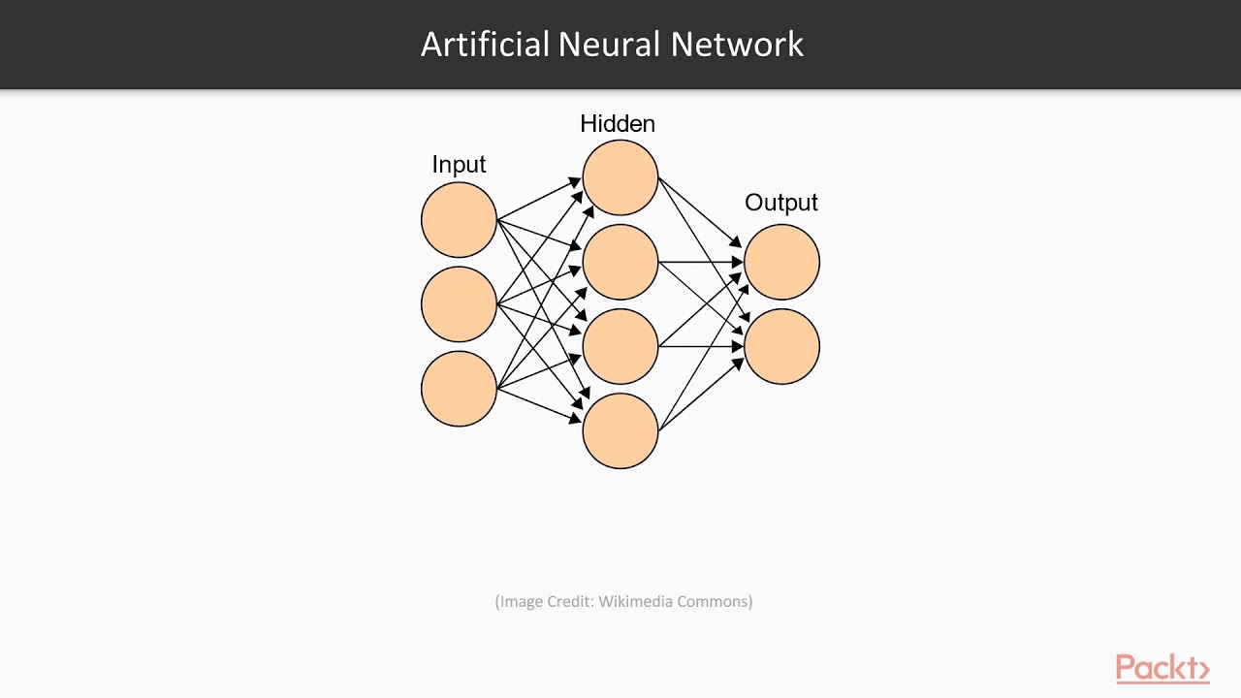

Figure 1.1: Deep learning architecture

**Figure 1.1 describes the architecture of deep learning which involves organizing artificial neural networks to process and learn from data. It starts with an input layer representing features and progresses through hidden layers with interconnected nodes. Each node applies an activation function to introduce non-linearity. Weights and biases influence these connections. The output layer provides predictions for the given task. Loss functions quantify prediction errors, optimized via algorithms like gradient descent. Training involves forward and backward passes, adjusting weights. Hyperparameters, like learning rate and layers, affect model behaviour. Architectures vary, like CNNs for images and RNNs for sequences, chosen based on task and data. Experimentation and tuning refine model performance.**

**A Convolutional Neural Network (CNN) is a type of deep learning model specifically designed for processing grid-like data, such as images and videos.** Using convolutional neural networks, I use the ideas of deep learning, which a subfield of machine learning, in this research. **It's widely used in computer vision tasks like image classification, object detection, and segmentation due to its ability to efficiently learn and extract features from visual data. Here some overview of common types of CNNs**

* Standard CNN consist of convolutional layers followed by activation functions (like ReLU), pooling layers (such as max-pooling), and fully connected layers. Convolutional layers apply filters to detect patterns like edges or textures, and pooling layers down sample to reduce spatial dimensions.
* LeNet5 is one of the earliest CNN architectures, it uses a combination of convolutional layers, pooling layers, and fully connected layers. It extracts features through convolution and pooling, followed by flattening and fully connected layers for classification.
* AlexNet is a pioneering CNN architecture that introduced deep neural networks. It consists of several convolutional and pooling layers, followed by fully connected layers. It uses ReLU activations and employs dropout to reduce overfitting.
* VGG architectures are characterized by their simplicity and use of small 3x3 convolutional filters. The network architecture involves stacking multiple layers with 3x3 convolution followed by a max-pooling layer.
* ResNet uses residual blocks with shortcut connections (skip connections) to address the vanishing gradient problem. It enables training very deep networks by allowing the network to learn residuals, making it easier to optimize.
* V3 architectures employ inception modules that use multiple filter sizes within the same layer. This allows the network to capture features at multiple scales and improves efficiency.
* MobileNet is designed to be computationally efficient and lightweight, making it suitable for mobile and embedded devices. It employs depth-wise separable convolutions to reduce computation and model size while maintaining accuracy.

In above types Standard CNN (sequential model) is used for this project due to its ability to organize layers in a linear sequence, making it intuitive and easy to define the architecture for image processing task pneumonia detection.

In CNN Development phase involves First, a large dataset of labelled medical images is collected, consisting of both normal and pneumonia-infected cases. This dataset serves as the training data for the machine learning model. The model is then trained using various algorithms and techniques, allowing it to learn and identify patterns, features, and abnormalities associated with pneumonia. Once the model is trained, it is tested on a separate dataset to evaluate its performance and accuracy. The evaluation phase helps to determine the effectiveness of the model in accurately detecting pneumonia cases. Iterative refinement of the model may be carried out to improve its performance and address any limitations or challenges identified during the testing phase.

Model develops a trustworthy, effective, and user-friendly system that can help medical professionals diagnose pneumonia quickly. A system like this can help with fewer diagnostic blunders, quicker treatment, and better patient results. By utilizing the capabilities of artificial intelligence and machine learning, the pneumonia detection initiative advances medical technology. The automated detection system has the potential to improve the diagnosis of pneumonia, speed up treatment, and lessen the strain on medical staff, resulting in better patient care and results for respiratory health.

**1.2 Convolution Neural Network**

Convolution Neural Network was used for this project. A Convolutional Neural Network (CNN) is a type of Deep Learning neural network architecture commonly used in Computer Vision. Computer vision is a field of Artificial Intelligence that enables a computer to understand and interpret the image or visual data. CNN makes it simple to extract spatial and temporal features from images. Each layer has a unique weight since CNN uses a weight-sharing strategy to cut down on computation time. Create and use a CNN architecture that is appropriate for detecting pneumonia.

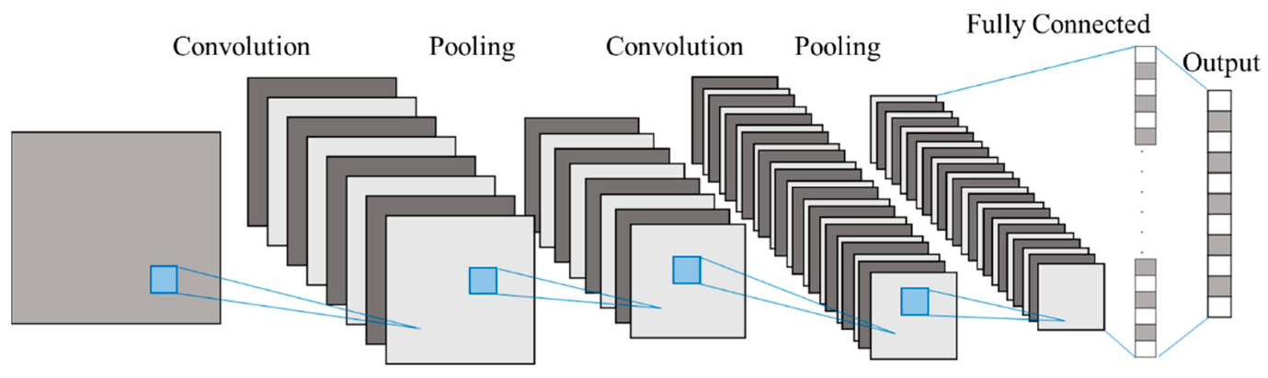

Figure 1.2: CNN Architecture

Figure 1.2 explains architecture of CNN, The CNN typically consists of multiple convolutional layers, pooling layers, and fully connected layers. It uses convolutional layers for feature extraction, activation functions for non-linearity, and pooling layers for dimensionality reduction. Fully connected layers connect features for complex pattern learning, and the output layer produces predictions. The architecture is effective in image-related tasks, employing convolution, activation, pooling, and fully connected layers.

**1.2.1 CNN Layers**

CNN's architecture is often composed of several layers, each having a distinct purpose. CNN Layers described in figure 1.3. CNN processes input data with the use of convolutional layers, Following each convolution, a non-linear activation function present. After that, layer pooling reduces spatial dimensions. The features that arise are flattened into a 1D vector and fed into fully connected layers that learn higher-level representations. The output layer generates predictions suited to the individual job, and a loss function quantifies prediction accuracy. The network modifies its parameters to minimize loss using backpropagation and optimization methods, iteratively improving prediction quality over repeated training epochs.

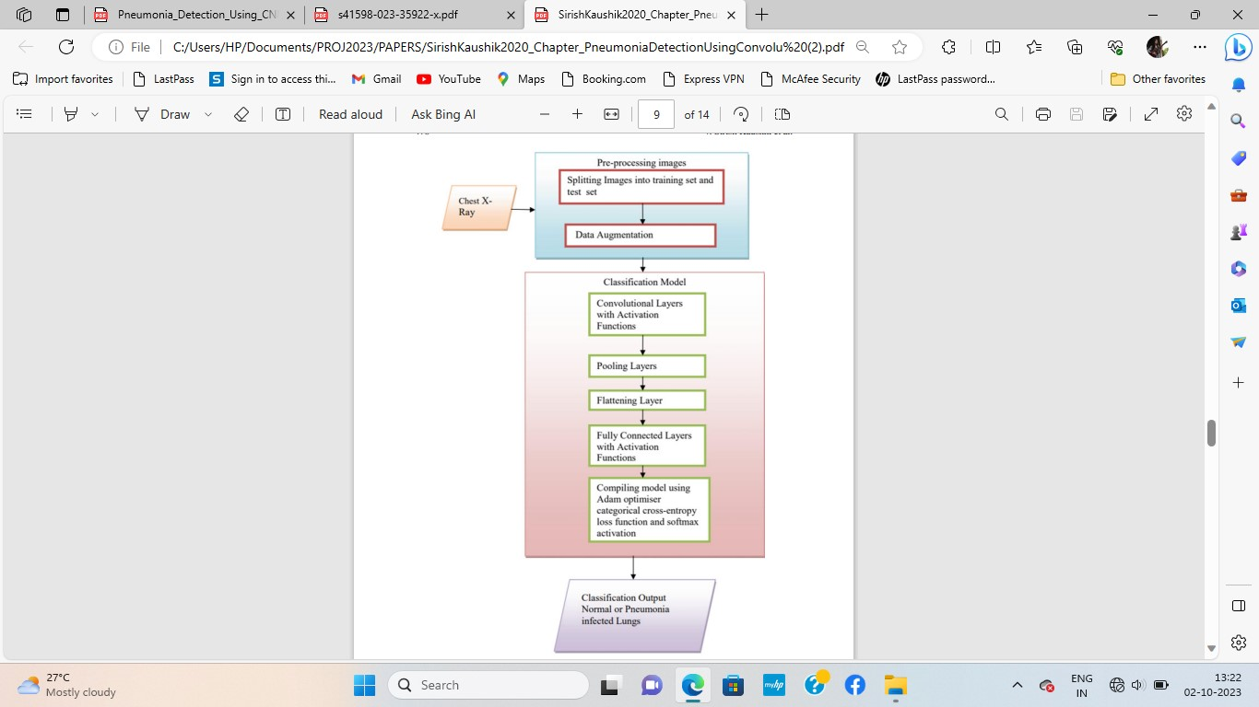

Figure 1.3: CNN Layers

* **Convolution Layer**

**Convolutional layers are designed to extract local features from input data by applying convolution operations. This layer is capable of identifying numerous patterns, such as edges, corners, or textures, in diverse input regions.**

Convolution layer is added using Conv2D class. It consists of parameters like filters, kernel size, strides, padding, activation function, and input size. Filter is an integer representing the number of output filters (or kernels). Each filter learns a unique feature from the input data. Kernel size is a tuple of two integers indicating the height and breadth of the 2D convolution window (for example (3,3)). Strides is a pair of numbers that determine the step size along the height and breadth of the convolution. Padding is one of 'valid' or 'same'. 'Valid' means no padding, 'same' means padding the input such that the output has the same height and width as the input. And the activation function applied to the convolution output. Shape of the input data only used in the first layer.

* **Activation Function**

The activation function is a crucial component within each layer of a neural network, including Convolutional Neural Networks (CNNs). It introduces non-linearity into the model, allowing it to learn complex patterns and relationships in the data.

ReLU is widely used and effectively addresses the vanishing gradient problem. It activates a neuron if the input is positive otherwise, it outputs zero. It promotes faster convergence during training by enabling a more linear approximation of the underlying function, aiding in learning complex features. It applied after each Convolution layer, introducing non-linearity and allowing the model to learn and adapt its features effectively. It defines mathematical function as

f(x)=max (0, x)

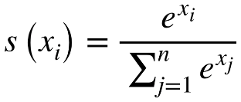Softmax is a type of activation function that takes a vector of numbers as input and transforms them into probabilities that sum up to 1. It's often used in the output layer of a neural network for multi-class classification problems.

* **Pooling Layer**

The pooling layer's primary goal is to gradually reduce the spatial dimensions of the input volume (width and height) while maintaining the depth (number of channels). Common pooling operations include Max Pooling and Average Pooling. Max Pooling takes the maximum value from a group of neighboring pixels in each channel of the input. Average Pooling computes the average of a group of neighboring pixels. Figure 1.4 describes both average and max pooling techniques.

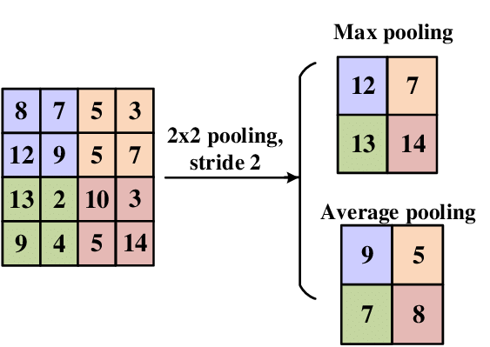

Figure 1.4: Pooling

* **Flatten Layer**

Here the Flatten layer converts multidimensional output from preceding layers into a one-dimensional vector, easing the transition from convolutional or pooling layers to fully connected layers. It concatenates elements along the depth axis, simplifying network architecture and facilitating successful feature learning for future tasks.

* **Fully Connected Layer**

Fully Connected Layer is designed to connect every neuron from the previous layer to every neuron in the current layer, creating a fully connected structure. Each neuron in the layer receives input from all the neurons in the previous layer. The output of each neuron is calculated by a weighted sum of its inputs, where the weights are parameters learned during training. During each training iteration, Dropout "drops out" the neurons. During that iteration, the neurons that have been dropped out do not participate to the forward or backward passes. Dropout is frequently used after Dense (completely linked) layers and can also be utilized in convolutional layers. It's a common choice in many architectures, especially deep learning models.

Metrics are used to evaluate the model's performance during and after training. Common metrics include accuracy, precision, recall, etc. The metric being monitored during training is accuracy. Accuracy measures the proportion of correctly classified samples, providing an evaluation criterion for the model's performance

**1.3 Need of CNN**

Not using CNNs would require manual feature engineering, potentially leading to suboptimal performance and increased complexity. CNNs excel in understanding spatial relationships in image data, making them well-suited for medical imaging tasks. Some other challenges are Feature Representation, Limited Performance, Difficulty in Adaptability, Expertise Requirement and so on.

Using Convolutional Neural Networks (CNNs) is optimal for this project due to their ability to automatically extract features from medical images, especially complex patterns critical for accurate diagnosis. That’s why CNNs are a preferred choice for my project due to their ability to automatically learn relevant features from images and effectively capture complex patterns. While you can explore alternatives, it's essential to consider the potential trade-offs in terms of performance, development complexity, and required expertise.

**1.4 Challenges**

There are many challenges have emerged throughout this project, and they encompass:

* **Class imbalance:** Due to the large number of images for pneumonia and the little number of photos for normal in the dataset, there is a problem during model training where the model is highly trained for pneumonic and produces incorrect results.
* **Data Quality and Noise: The dataset utilized for this project has a lot of noise in the images, such as blurriness or resolution, which causes issues during the training phase and may confuse the system and result in incorrect output.**
* **Overfitting: Utilizing a small amount of data is essential since models occasionally only produce results for one class due to overfitting caused by greater data.**
* Model Sensitivity and Specificity: To prevent false positives and false negatives, it's crucial to strike a balance between sensitivity (accurately detecting pneumonia patients) and specificity (accurately identifying non-pneumonia cases).
* **Limited Data Availability:** Obtaining a large, diverse, and well-annotated dataset of chest X-ray images can be challenging due to limitations in data availability, there is only one dataset is available on internet for pneumonia detection project.
* **Algorithm Robustness:** Real-world applicability depends on the model performing well across a variety of patient demographics, circumstances, and picture quality differences.
* **Model generalization:** The key to successful pneumonia diagnosis in real-world scenarios is the development of a model that generalizes effectively to unknown data, including various demographics and conditions.

As the project moves further, several other motives are important to overcome these obstacles certain of them are Improving Patient Outcomes, Enhancing Healthcare Efficiency, Empowering Healthcare Professionals, these technologies have the potential to help identify pneumonia early and precisely, which might greatly enhance patient outcomes and possibly save lives. Positive Social Impact, by advancing medical technology and maybe lightening the load on the healthcare system, the project can have a wider, positive impact on society. Contributing to Research and Innovation, the initiative has the potential to expand the field of medical image analysis and pave the way for next advances while providing the scientific community with useful insights and advancements.

**1.5 Evaluation Metrics**

The report displays key classification metrics, including precision, recall, and F1-score, calculated separately for each class. These metrics are calculated using the predictions and true labels obtained from the model's output. True table (Figure 1.4) consists of true and false positives, true and false negatives.

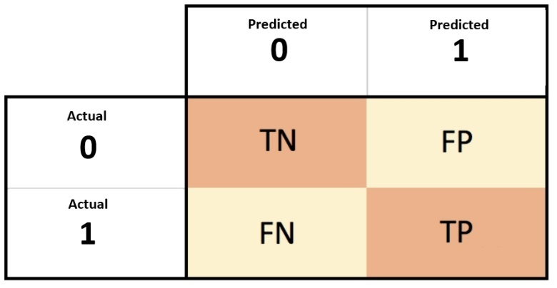

Figure 1.4: True Table

* **True Positives (TP):** The number of instances that were correctly predicted as positive (the model predicted as positive, and it was actually positive).
* **True Negatives (TN):** The number of instances that were correctly predicted as negative (the model predicted as negative, and it was actually negative).
* **False Positives (FP):** The number of instances that were predicted as positive but were actually negative (the model predicted as positive, but it was actually negative).
* **False Negatives (FN):** The number of instances that were predicted as negative but were actually positive (the model predicted as negative, but it was actually positive).

**1.6 Classification Metrics**

Classification metrics are used to assess the effectiveness of machine learning models developed to perform classification tasks. These metrics reveal how successfully the model predicts and classifies examples into predefined groups or classes. Here are some well-known metrics used in this project:

1. **Precision:**

Precision is a classification metric that measures the proportion of true positive predictions (correctly identified positive instances) out of the total predicted positive instances (sum of true positives and false positives). In other words, it calculates the accuracy of the positive predictions made by the model.

The formula for precision is:

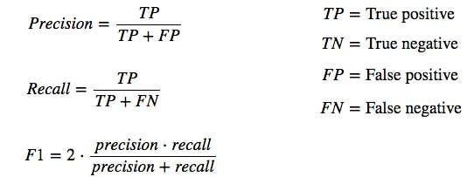

Where,

* True Positives (TP): The number of instances that were correctly predicted as positive by the model.
* False Positives (FP): The number of instances that were incorrectly predicted as positive by the model (i.e., they were actually negative).

1. **Recall:**

Recall, also known as sensitivity or true positive rate, is a classification metric that measures the proportion of true positive predictions (correctly identified positive instances) out of the total actual positive instances. Recall calculates the model's ability to capture all the relevant instances of a specific class.

The formula for recall is:



Where,

* True Positives (TP): The number of instances that were correctly predicted as positive by the model.
* False Negatives (FN): The number of instances that were incorrectly predicted as negative by the model (i.e., they were actually positive).

1. **F1-Score:**

The F1 score is a classification metric that combines both precision and recall into a single value, providing a balance between the two metrics. It is the harmonic mean of precision and recall and is often used to assess a model's performance, especially when dealing with imbalanced datasets or when both false positives and false negatives are important.

The formula for the F1 score is:



Where,

* Precision: The proportion of true positives (correctly identified positive instances) out of the total predicted positive instances.
* Recall: The proportion of true positives out of the total actual positive instances.

**1.7 Objectives**

The main objective of this project is to create an effective system for pneumonia detection using Chest x-ray images by applying machine learning and deep learning techniques like CNN and enhancing early diagnosis and treatment of pneumonia through technology-based assistance.

**1.8 Dataset Description**

After analysing and reading various datasets available on various platforms and websites, Chest x-ray dataset (pneumonia) from Kaggle was found to be best fit for performing on and making a model to detect it using image dataset of chest X-rays of patients. So, for this project Chest x-ray images (pneumonia) dataset was used. The images provide a view of a patient's chest and are used for detecting pneumonia. It comprises thousands of chest X-ray images.

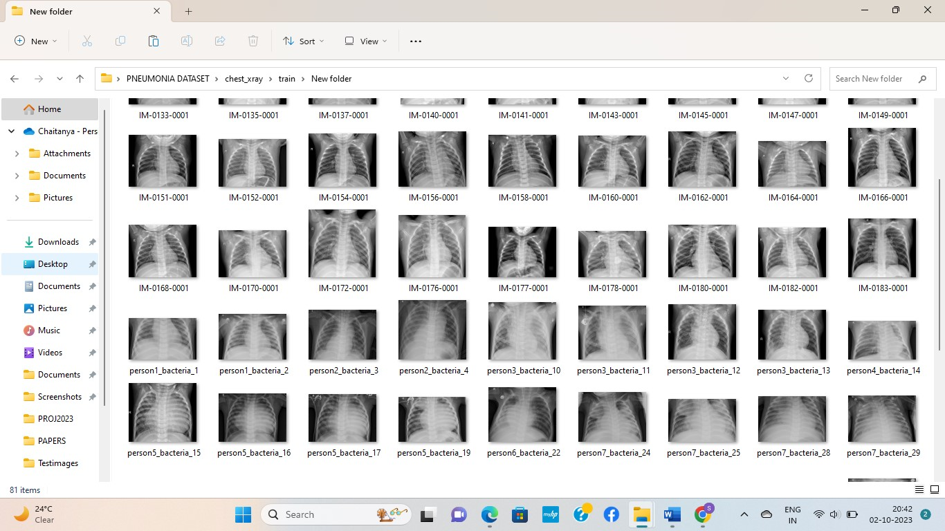Figure 1.5: Chest X-ray images

The above figure 1.5 shows Chest x-ray images which consists both pneumonic and normal chest x-rays. After that it is divided into two main categories, pneumonia-positive and pneumonia-negative cases. Chest X-rays of pneumonia patients are given the designation "pneumonia-positive," which denotes the presence of a lung infection and "pneumonia negative" which serves as the control or negative class. Dataset primarily consists of chest X-ray images in JPEG format. Dataset contains of 4260 pneumonic images and 1570 normal shown in Table 1.1.

Table1.1: Count of images on dataset

|  |  |
| --- | --- |
| **Directory** | **Count** |
| Normal | 1570 |
| Pneumonia | 4260 |

**1.8.1 Classes in Dataset**

* **Pneumonic**

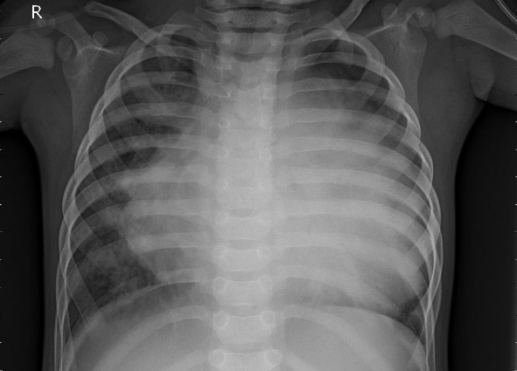

Figure 1.6: Pneumonic image

Figure 1.6 consists pneumonic chest x-ray image which displays lungs with cloudy or hazy patches, indicating areas filled with fluid and inflammation. These patches appear whiter than normal lung tissue. Pneumonia can affect one or both lungs, and the cloudy areas may be spread throughout or concentrated in specific regions. The lung borders may not be as clear as in a normal X-ray due to the infection. Additional signs, like fluid around the lungs or changes in the heart area, might also be visible.

* **Normal**

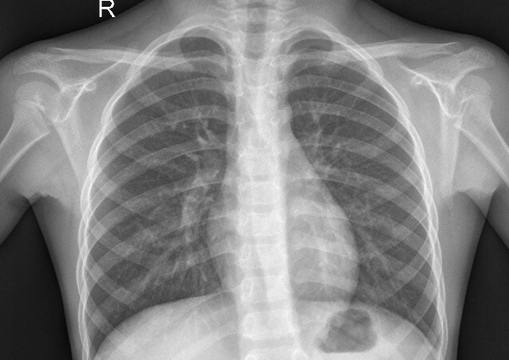

Figure 1.7: Normal image

Figure 1.7 displays healthy lung structures with clear and symmetrical lung fields. The trachea and main bronchi should be unobstructed. The heart and mediastinum appear normal, while ribs and bony structures are intact.

**2**.**LITERATURE REVIEW**

2.1 Literature Survey

The similarities between healthcare and technology made the diagnosis of disease simple and effective. Healthcare has been altered by technology. Lung cancer, pneumonia, and other disorders can be detected using it. Deep learning has unlocked new keys for image analysis, making the diagnosis of disease faster, and accurate. In deep learning, the most important and widely used application in image analysis is X-ray. Pneumonia endemic nations struggle with a number of issues, including the lack of and affordable, quick, and effective diagnostic equipment that can be used in the field. Several methods have been proposed till now for identification of pneumonia.

Pneumonia chest x-ray can be observed in TB, severe case of bronchitis as well. To determine the infection, additional tests such as a sputum test, chest computed tomography (CT), and complete blood count (CBC) are performed. As a result, in this attempt to tackle the problem, we have merely attempted to determine whether a chest x-ray indicates that a person is suffering from pneumonia or is simply a normal patient by looking for any foggy patterns in the X-ray. Therefore, only pathology tests will be able to provide a conclusive diagnosis.

Tatiana Gabruseva, et al. explore a study "Deep Learning for Automatic Pneumonia Detection" [1] by University of Michigan, an innovative approach to automated pneumonia detection. Central to this approach are Convolutional Neural Networks (CNNs), which play a pivotal role in image analysis and feature extraction, forming the foundation for accurate pneumonia detection. The model's architecture is a strategic fusion of RetineNet SSD framework and Se-ResNext101 encoders, pre-trained on the ImageNet dataset, showcasing an advanced design to optimize performance. Remarkably, this model exhibits an impressive accuracy rate of 87.5%, showcasing its efficiency in automating pneumonia detection a significant stride towards rapid and precise diagnosis. A crucial aspect of this success is attributed to the utilization of the RSNA Pneumonia Detection Challenge Dataset, a reputable benchmark sourced from the Radiological Society of North America (RSNA). This dataset stands as a vital resource for training and validating the model, ensuring its reliability and relevance in real-world clinical scenarios.

Rahul Nijhawan, et al. explore this project “Pneumonia Detection Using CNN based Feature Extraction” [2] using Convolutional Neural Networks (CNNs) with a specific focus on 'Densely Connected Convolutional Neural Network' (DenseNet-169). With an achieved accuracy of 80%, the model demonstrates competence in automating pneumonia detection, showcasing its potential for clinical applications. The dataset employed for this study is the ChestX-ray14, released by Wang et al. in 2017, a pivotal resource for training and validating the model. The research employs a notable technique that involves utilizing DenseNet-169 in conjunction with SVM (Support Vector Machine), achieving a notable accuracy of 80.02%. This technique signifies an effective fusion of deep learning with traditional machine learning, highlighting its relevance in medical image analysis. The integration of DenseNet-169, a potent deep learning architecture, showcases the significance of advanced models in enhancing diagnostic accuracy.

Marwa M. Eid, et al. titled "Efficient Pneumonia Detection for Chest Radiography Using ResNet-Based SVM" [3] to successfully detect pneumonia in chest radiography. The study makes use of a Support Vector Machine (SVM) Classifier, specifically the Vapnik-developed SVM, in conjunction with ResNet, demonstrating a blend of traditional and contemporary methodologies to improve diagnosis accuracy. The success of their strategy is demonstrated by a remarkable accuracy of 98.13%, underscoring the potential of incorporating ResNet-based SVM for accurate pneumonia identification. The scientists make use of a Kaggle dataset that includes chest X-ray images of pneumonia cases. The SVM model can be trained and validated successfully using this dataset as a base component.

Pranav Rajpurkar, Kaylie Zhu, et al. worked on "CheXNet: Radiologist-Level Pneumonia Detection on Chest X-Rays with Deep Learning," [4] use the CheXNet model to diagnose pneumonia at the radiologist-level. With a remarkable accuracy of 95%, the CheXNet model presented in this study has the potential to greatly improve pneumonia identification in chest X-rays. Utilizing the Chest X-ray14 dataset, an established resource in the field, the study underscores the importance of reliable and comprehensive datasets for training and evaluating deep learning models. The Chest X-ray14 dataset is a crucial asset, providing a diverse range of chest X-ray images essential for training the CheXNet model effectively. This achievement brings the medical community closer to achieving radiologist-level accuracy in pneumonia detection, showcasing the transformative potential of deep learning in medical imaging.

Alaa M. A. Barhoom and Prof. Dr. Samy S. Abu Naser study "Diagnosis of Pneumonia Using Deep Learning" [5] which focus around leveraging deep learning techniques for accurate pneumonia diagnosis. The study prominently features Convolutional Neural Network (CNN) models, particularly the VGG16 networks, as a foundational element for their approach. Impressively, the model achieves a perfect accuracy rate of 100%, underscoring its potential as a highly reliable diagnostic tool for pneumonia detection. This achievement emphasizes the significance of CNN models and their capacity to excel in image-based medical diagnoses. For training and evaluation, the researchers utilized the Chest X-Ray Images (Pneumonia) Dataset obtained from the National Institutes of Health (NIH) database. This dataset, a reputable source, proves essential in training the CNN models effectively, contributing to the model's robustness and accuracy.

Ebru Erdem, Tolga Aydın, et al. introduce "Detection of Pneumonia with a Novel CNN-based Approach", [6] an innovative CNN-based methodology for precise pneumonia detection. Their approach leverages CNN-based models, particularly the proposed model, alongside well-established architectures like VGG16 and VGG19. For training and verifying their CNN-based models, the researchers used a dataset containing chest X-ray pictures. The robustness of the suggested approach is enhanced by the inclusion of chest X-ray pictures, which guarantees that the models are exposed to a variety of situations. Their innovative CNN-based technique has the potential to dramatically improve pneumonia identification and diagnosis, as shown by their excellent accuracy of 88.62%. The outcomes highlight the effectiveness of CNN-based architectures for illness identification and image analysis in the medical field.

Muhammad Umar Khan, et al. explore "An Automated System Towards Diagnosis of Pneumonia using Pulmonary Auscultations" [7] to work on automate pneumonia diagnosis by pulmonary auscultations analysis. This is a brand-new method of diagnosing illness. The work emphasizes the effective classification and accurate diagnosis of pneumonia using Support Vector Machine (SVM) models, especially SVM-Quadratic. The proposed automated system's high accuracy rate of 99.7% exemplifies its efficacy and efficiency. The research's dataset, which focuses on lung sound data, is an important feature. Using pulmonary auscultations to diagnose pneumonia, the SVM models' accuracy and dependability are ensured by training and verifying them on this particular dataset.

A. Sharma, et al. from Bharati Vidhyapeeth’s College of Engineering, New Delhi, they explore "Detection of Pneumonia using ML & DL in Python” [8] where primary focus is on pneumonia detection employing Machine Learning (ML) and Deep Learning (DL) techniques. Python, a versatile programming language, is utilized to implement these methodologies. The study makes extensive use of a Kaggle chest X-ray dataset, highlighting its value as a thorough and easily available data source for developing ML and DL models. Through this dataset, the researchers highlight the usefulness and real-world applicability of their methodology. This study demonstrates the effectiveness and precision of their methodology by reaching an astounding accuracy rate of 98.2%. This demonstrates how well CNN models work for analysing medical images and identifying diseases. And their research significantly contributes to the field of pneumonia detection, impacting healthcare positively

Rabia Emhamed Al Mamlook, et al. introduced "Investigation of the performance of Machine Learning Classifiers for Pneumonia Detection in Chest X-ray Images" [9] research focuses on evaluating machine learning classifiers for accurate pneumonia detection in chest X-ray images. A range of machine learning models, including Random Forest, Xgboost, K-nearest neighbor, Decision Tree, Gradient Boost, Adaboost, and Convolutional Neural Network (CNN), were implemented and compared to assess their performance in pneumonia detection. The dataset used in this research comprises chest X-ray images, a vital resource for training and evaluating the machine learning models. The utilization of this dataset ensures the robustness and reliability of the models in pneumonia detection. The results presented in below fig show that accuracy of Pneumonia Image Classification. The highest accuracy was 98.46% to deep learning, On the other hand, the decision tree classifier achieved the lowest performance of 85.64%.

S. Graceline Jasmine, et al. conducted research named "Analysis of pneumonia detection systems using deep learning-based approach" [10] that is focused on evaluating these systems. They choose best model by analysing all the models and classification. Finally, they conclude from reviews that, CNN VGG19 and the SVM classifier got the best pneumonia detecting model using CXR images since This method had a 96.47 percent accuracy, a 97.47 percent sensitivity score, a 95.56 percent F1 score, and a 97.56 percent accuracy. The dataset employed is curated to diagnose pneumonia in both Chest X-rays and CT images, reflecting a comprehensive approach to disease detection. The diversity of images within this dataset ensures the models' proficiency and adaptability to different medical imaging modalities.

Veeranjaneyulu Naralasetti, et al. worked on "Deep Learning Models for Pneumonia Identification and Classification Based on X-Ray Images" [11] this study use Deep Convolutional Neural Network models for precise pneumonia identification and classification. The work demonstrates the value of cutting-edge deep learning methods, in particular CNN models, in improving the accuracy of diagnosing pneumonia using X-ray images. Chest X-ray datasets and benchmark datasets are included in the dataset used in this study, providing a thorough basis for training and verifying the deep CNN models. The model demonstrates its efficiency in automating the diagnosis and classification of pneumonia with a noteworthy accuracy rate of 91.17%, resulting in sped up diagnostic procedures and enhanced patient care.

Wachiraphong Ratiphaphongthon, et al. research, "An Improved Technique for Pneumonia Infected Patients Image Recognition," [12] attempts to improve pneumonia recognition in patient images using a cutting-edge combination algorithm. The study's main focus is the application of an SVM model, demonstrating its potential for precise image recognition, notably for locating patients with pneumonia. The study demonstrates an enhanced technique for picture recognition by using a combination algorithm of Smooth Generalized Pinball SVM and Variational Autoencoders. The SVM-based approach demonstrates ability in obtaining accurate predictions, contributing to improved diagnostic outcomes for pneumonia diagnosis, with the best prediction accuracy up to 57% to 64%. The dataset employed comprises chest X-ray (CXR) images, encompassing both binary and multiclass datasets. These datasets form a crucial foundation for training and validating the SVM model, ensuring its robustness and reliability in pneumonia image recognition.

Abhir Bhandary, et al. they work on development of a deep-learning framework for detecting lung abnormalities using chest X-ray and lung CT scan images is the main goal of the study "Deep-Learning Framework to Detect Lung Abnormality," [13]. The study makes use of a Support Vector Machine (SVM) model extensively to demonstrate how well it can detect lung problems in medical images. Chest X-rays and lung CT scan images make up the dataset, which illustrates the range and complexity of medical imaging data used to train the SVM model. The resilience and adaptability of the paradigm in practical applications are ensured by this diversity. With a noteworthy accuracy of 96.80%, the model demonstrated the effectiveness of the selected SVM-based method and its function in automating the detection of lung anomalies.

Harshvardhan GM, et al. conduct research on "Pneumonia Detection Using CNN through Chest X-ray" [14] which focuses on employing Convolutional Neural Networks (CNN) for accurate pneumonia detection in paediatric patients aged one to five. The dataset utilized in this study comprises chest X-rays collected from paediatric patients at Gangzhou Women and Children’s Medical Centre, Gangzhou, as detailed by Kermany et al. The study focuses on methods for image augmentation to increase dataset variability, which helps in model training and validation. And uses a convolutional neural network (CNN) and an artificial neural network (ANN) to diagnose pneumonia, demonstrating the utility of deep learning for this type of picture analysis. Key evaluation measures like sensitivity and specificity, both above 90% and at 0.9007 and 0.9216, respectively, show how well the model performs in spotting positive pneumonia cases while successfully excluding negative instances.

Narayana Darapaneni, et al. worked on "Pneumonia Detection in Chest X-Rays using Neural Networks" [15] which employing a CNN architecture for binary classification of X-ray images. The dataset utilized, RSNA - CXR Dataset, comprises 30,227 X-ray images in Dicom format, categorized into three classes: 31.61% lung opacity, 39.11% no lung opacity, and 29.28% normal images. The CNN architecture employed demonstrates promising results, with a final accuracy of 95% on the training set and 79% on the validation set at the 25th epoch. These results highlight the efficiency of CNN-based methods for correctly identifying pneumonia in chest X-rays, highlighting future developments in medical image analysis for enhanced healthcare diagnostics.

V. Sirish Kaushik, et al. research on "Pneumonia Detection Using Convolutional Neural Networks (CNNs)" [16] which use CNNs for accurate detection of pneumonia using chest X-ray images. The dataset utilized in this study is the Chest X-Ray Images (Pneumonia) dataset, total 1.16 GB in size, imported from Kaggle, highlighting the significance of large datasets in model training. The study evaluates multiple CNN models, with specific attention to model 3 with three convolutional layers and model 4 with four convolutional layers. The results showcase the effectiveness of these models, with model 3 achieving a validation accuracy of 92.31%, recall of 98%, and an F1 score of 94%. Furthermore, model 4 closely follows in performance, achieving a validation accuracy of 91.67%, recall of 98%, and an F1 score of 94%, highlighting the robustness of CNN-based approaches for pneumonia detection. These results signify the potential of utilizing CNNs in medical imaging, specifically in detecting pneumonia, showcasing promising outcomes that contribute to the field of healthcare diagnostics.

Sukhendra Singh, et al. work on "Pneumonia Detection with QCSA Network on Chest X-rays" [17] by utilizing Quaternion Convolution Neural Network (QCNN) as an extension of the real CNN model for pneumonia detection in chest X-ray images. The QCNN model showcases its effectiveness in accurately detecting pneumonia, achieving an impressive accuracy rate of 94.53%, underscoring its potential in medical image analysis. The Kaggle X-ray dataset was used in this study, and it serves as a good example of the value of using a variety of datasets to train and validate the QCNN model and ensure its reliability. Quaternion convolutional neural networks (QCNNs) represent a notable advancement in the domain of medical image analysis, particularly in pneumonia detection, showcasing their promise in improving diagnostic outcomes.

Muazzez Buket Darici, et al. conduct a study on "Pneumonia Detection and Classification Using Deep Learning on Chest X-Ray Images" [18] which focuses on leveraging Convolutional Neural Networks (CNN) and Artificial Neural Networks (ANN) for precise pneumonia detection and classification. The study achieves an accuracy of 78%, illustrating the efficacy of CNN and ANN models in accurately detecting and classifying pneumonia cases within chest X-ray images. The dataset utilized comprises chest X-ray images, a vital component in training and validating the CNN and ANN models, ensuring their proficiency in pneumonia detection and classification. This research signifies a significant advancement in the field of medical image analysis, specifically in pneumonia detection, showcasing the potential of deep learning methodologies.

Issac Neha Margret, et al. study the "Classification of X-ray Images for Pulmonary Diseases Using Deep Learning Techniques" [19] which employs Convolutional Neural Network (CNN) and Recurrent Neural Network (RNN) models to achieve highly accurate classification of X-ray images related to pulmonary diseases. The proposed approach involves a systematic workflow, including data collection, data pre-processing, and performance analysis of CNN and RNN models, culminating in model deployment. The dataset used in this study, which focuses on chest X-ray pictures, was obtained from Kaggle. The robustness and dependability of the CNN and RNN models are ensured by this dataset, which is a crucial component of data collection and training. The usefulness and precision of the CNN and RNN models in the classification of chest X-ray pictures is demonstrated by an astounding accuracy of 95.9%, highlighting their promise in medical image analysis.

Tawsifur Rahman, et al. work on "Transfer Learning with Deep Convolutional Neural Network (CNN) for Pneumonia Detection Using Chest X-ray" [20] which uses various CNN types and pre-trained algorithms like AlexNet, ResNet18, DenseNet201, and SqueezeNet for accurate pneumonia detection in chest X-ray images. Utilizing the Kaggle chest X-ray pneumonia dataset, this research ensures a diverse and comprehensive dataset, critical for training and validating the models, thus enhancing their proficiency and reliability. The achieved accuracy of 93.28% underscores the effectiveness and precision of the utilized CNN models, with DenseNet201. That is DenseNet201 demonstrated a test accuracy of 98% for normal vs. pneumonia, 93.3% for normal, bacterial, and viral pneumonia, and 95% for bacterial and viral pneumonia classification.

Deniz Yagmur Urey, et al. use Convolutional neural network (CNN) and recurrent neural network (RNN) models for the research on "Early Diagnosis of Pneumonia with Deep Learning" [21]. The dataset used in this study was published by the Radiological Society of North America and made available on Kaggle.com. The labels for the x-ray pictures in this collection indicate whether pneumonia is present or not. The study outperformed CheXNet's accuracy of 76% in classification with a precision of 78.73%, highlighting the efficacy of their method. CheXNet's accuracy was 76%. The improved pneumonia diagnosis accuracy that can be attained through model tuning shows promise and will ultimately result in better patient care.

So-Mi Cha, et al. entitled "Attention-Based Transfer Learning for Efficient Pneumonia Detection in Chest X-ray Images" [22] achieves a remarkable accuracy of 96.63% in the diagnosis of pneumonia using chest X-ray images. The dataset for this research includes chest X-ray images sourced from three distinct datasets: ImageNet, NIH dataset, and a custom dataset, ensuring comprehensive data representation. A unique approach involves concatenating feature vectors extracted from pre-trained models like ResNet152, DenseNet121, and ResNet18, allowing for the effective combination and utilization of each model's advantages as feature extractors. Among the pre-trained models, DenseNet121-based model demonstrated the highest accuracy, validating its effectiveness in enhancing pneumonia detection accuracy.

G. Jignesh Chowdary, et al. conduct study of, "Impact Of Machine Learning Models In Pneumonia Diagnosis With Features Extracted From Chest X-Rays Using VGG16" [23] with an impressive accuracy of 96.61% is achieved in diagnosing pneumonia. The dataset used comprises chest x-ray images from the ChestXRay2017 dataset developed by Daniel Kermany et al., focusing on pneumonia detection. VGG16 DCNN is employed to extract features from chest x-ray images, where the fully connected layers of VGG16 are removed to serve as an effective feature extractor. For classification, popular ML algorithms like Random Forest (RF), Logistic Regression (LR), and Support Vector Machine (SVM) are utilized. These algorithms are chosen based on their promising results in medical diagnosis. Finally, comparison of classifiers in different study is given below in Table 2.1

Table 2.1 Comparison with the previous studies

|  |  |  |  |  |  |
| --- | --- | --- | --- | --- | --- |
| **S. I** | **AUTHOR** | **TITLE** | **MODEL** | **DATASET** | **ACCURACY** |
| 1 | Tatiana Gabruseva, et al[1] | Deep Learning for Automatic Pneumonia Detection | CNNs (RetineNet SSD) | RSNA Pneumonia Detection Challenge Dataset | 87.5% |
| 2 | Dimpy Varshni, et al[2] | Pneumonia Detection Using CNN based Feature Extraction | CNNs (DenseNet-169) | ChestX-ray14 dataset | 80% |
| 3 | Marwa M. Eid, et al[3] | Efficient Pneumonia Detection for Chest Radiography Using ResNet-Based SVM | ResNet-Based SVM | Chest x-ray Kaggle dataset | 98.13%, |
| 4 | Pranav Rajpurkar, et al[4] | CheXNet: Radiologist-Level Pneumonia Detection on Chest X-Rays | CheXNet | ChestX-ray14 dataset | 95% |
| 5 | Alaa M. A. Barhoom, et al[5] | Diagnosis of Pneumonia Using Deep Learning | CNN models (VGG16) | NIH Chest X-Ray Images (Pneumonia) Dataset | 100% |
| 6 | Ebru Erdem1, et al[6] | Detection of Pneumonia with a Novel CNN-based Approach | CNN-based models (VGG16) | Chest x-ray Kaggle dataset | 88.62% |
| **7** | Sumair Aziz, et al[7] | An Automated System Towards Diagnosis of Pneumonia using Pulmonary Auscultations | Support Vector Machine (SVM) | Lung sound dataset | 99.7% |
| 8 | A Sharma1, et al[8] | Detection of Pneumonia using ML & DL in Python | Sequential CNN model | Kaggle Chest X-Ray dataset | 98.2% |
| 9 | Rabia Emhamed Al Mamlook, et al[9] | Investigation of the performance of Machine Learning Classifiers for Pneumonia Detection in Chest X-ray Images | Random Forest, Xgboost, K-nearest neighbor, Decision Tree, Gradient Boost, Adaboost, and Convolutional Neural Network (CNN) | Chest X-ray dataset | 98.46% for CNN |
| 10 | A.Beena Godbin, at al[10] | Analysis of pneumonia detection systems using deep learning-based approach | CNN VGG19 and SVM classifier | Chest X-rays and CT images dataset | 96.47% |
| 11 | Veeranjaneyulu Naralasetti1, et al[11] | Deep Learning Models for Pneumonia Identification and Classification Based on X-Ray Images | Deep Convolutional Neural Network | Chest X-ray datasets and benchmark datasets | 91.17% |
| 12 | Wachiraphong ratiphaphongthon, et al[12] | An Improved Technique for Pneumonia Infected Patients Image Recognition Based on Combination Algorithm of Smooth Generalized Pinball SVM and Variational Autoencoders | Support Vector Machine (SVM) | Chest X-ray (CXR) image dataset | 64% |
| 13 | Abhir Bhandarya, et al[13] | Deep-Learning Framework to Detect Lung Abnormality– A study with Chest X-Ray and Lung CT Scan Images | Support Vector Machine (SVM) | Chest X-rays and lung CT scan images dataset | 96.80% |
| 14 | Harshvardhan gm, et al[14] | Pneumonia Detection Using CNN through Chest X-ray | CNN | Chest X-rays collected from paediatric patients | 90% |
| 15 | Narayana Darapaneni, et al[15] | Pneumonia Detection in Chest X-Rays using Neural Networks | CNN | RSNA - CXR Dataset | 95% |
| 16 | V. Sirish Kaushik, et al[16] | Pneumonia Detection Using Convolutional Neural Networks (CNNs) | CNN | Chest X-Ray Images (Pneumonia) dataset(1.12GB) | Above 90% |
| 17 | Sukhendra Singh1, et al[17] | Pneumonia Detection with QCSA Network on Chest X-rays | Quaternion convolutional neural networks (QCNN) | Chest X-ray image dataset | 94.53% |
| 18 | Muazzez Buket DARICI, et al[18] | Pneumonia Detection and Classification Using Deep Learning on Chest X-Ray Images | ANN and CNN | Chest X-ray image dataset | 78% |
| 19 | Issac Neha Margret, et al[19] | Classification of X-ray Images for Pulmonary Diseases Using Deep Learning Techniques | CNN And RNN | Chest X-ray pictures | 95.9% |
| 20 | Tawsifur Rahman, et al[20] | Transfer Learning with Deep Convolutional Neural Network (CNN) for Pneumonia Detection Using Chest X-ray | CNN- DenseNet201 | Kaggle chest X-ray pneumonia dataset | 93.28% |
| 21 | Deniz Yagmur Urey, et al[21] | Early Diagnosis of Pneumonia with Deep Learning | CNN And RNN | Chest x-ray pictures by the Radiological Society of North America and made available on Kaggle.com | 76% |
| 22 | So-Mi Cha, et al[22] | Attention-Based Transfer Learning for Efficient Pneumonia Detection in Chest X-ray Images | DenseNet121 | ImageNet, NIH dataset, and a custom dataset | 96.63% |
| 23 | G. Jignesh Chowdarya, et al[23] | Impact Of Machine Learning Models In Pneumonia Diagnosis With Features Extracted From Chest X-Rays Using VGG16 | VGG16 DCNN | ChestXRay2017 dataset developed by Daniel Kermany et al. | 96.61% |

**3.PROPOSED METHODOLOGY**

The proposed method comprises image preprocessing with an image reading, resizing and Grayscale conversion images. Then splitting data into training and testing, evaluation of Pneumonia classification with the CNN model. Figure 3.1 depicts proposed methodology of this project.

**CHEST X-RAY DATASET**

**DATA PREPROCESSING**

**READ IMAGE**

**RESIZING**

**GRAY SCALE**

**TRAINING 80%**

**SPLITTING DATA**

**TESTING 20%**

**CNN**

**MODEL**

**DATA VISUALIZATION**

**PERFORMANCE EVALUATION**

**CLASSIFICATION OUTPUT**

Figure 3.1: Block diagram for Proposed Methodology

**3.1 Chest X-Ray Dataset**

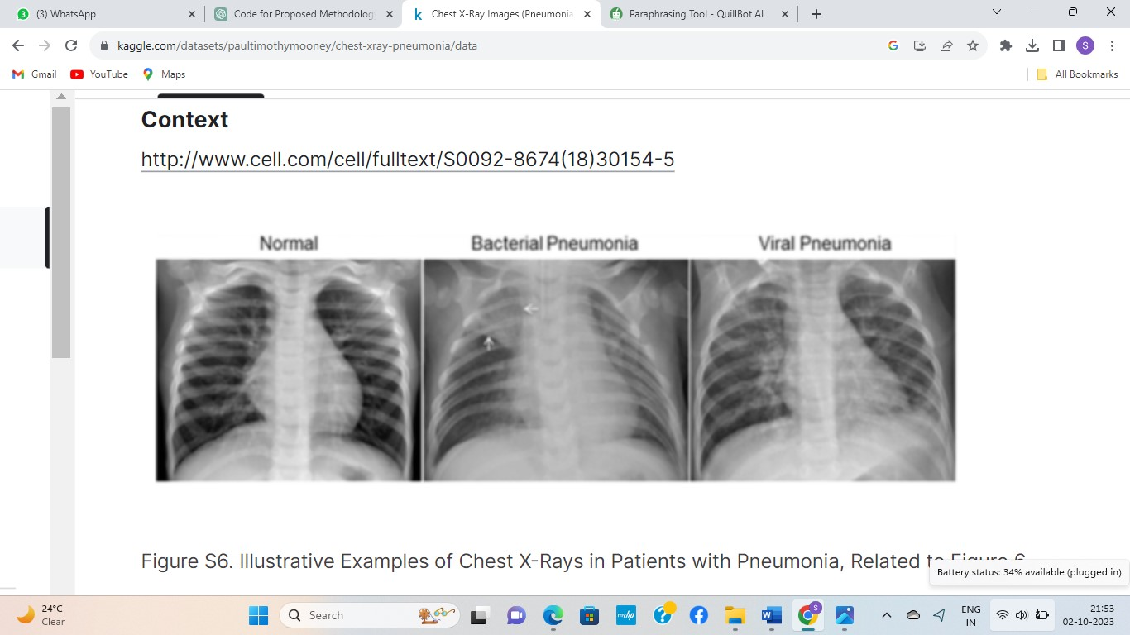Chest x-ray images (pneumonia) dataset from Kaggle was used for this project. The dataset primarily consists of chest X-ray images in JPEG format. The images provide a view of a patient's chest and are used for detecting pneumonia. It comprises thousands of chest X-ray images.

Figure 3.2: Illustrative Examples of Chest X-Rays in Patients with Pneumonia

Figure 3.2 illustrates a typical chest X-ray (left panel) with clear lungs and no areas of aberrant opacification in the image. Bacterial pneumonia (centre) is characterized by a focused lobar consolidation, in this example in the right upper lobe (white arrows), whereas viral pneumonia (right) is characterized by a more diffuse ''interstitial'' pattern in both lungs.

Chest X-ray images (anterior-posterior) were chosen from retrospective cohorts of paediatric patients aged one to five years at Guangzhou Women and Children's Medical Centre in Guangzhou. All chest X-ray imaging was done as part of the patient's regular clinical care. Before being analysed, all chest radiographs were checked for quality control, with all low quality or unreadable images being eliminated. Two qualified physicians rated the photographs' diagnoses prior to training the AI system. A third expert also went over the evaluation set to make sure there were no grading concerns.

Below bar chart (figure 3.3) represent a number of counts of pneumonic and normal chest x-ray images used in this project. Pneumonic chest x-rays represented in “Blue” coloured and Normal chest x-rays are in “Green” coloured. It represents the counts of "positives" and "negatives" in the dataset.

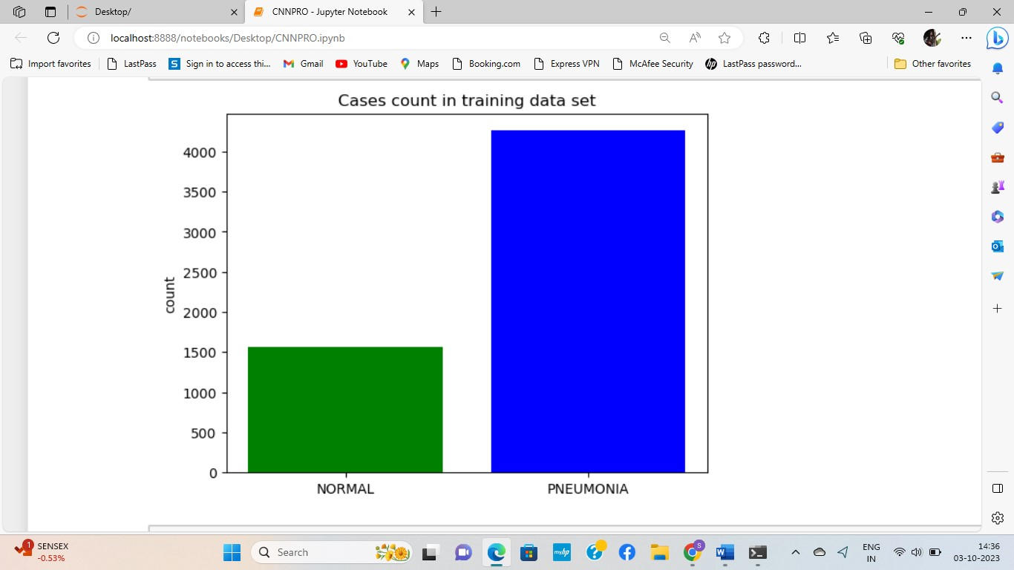

Figure 3.3: Representation of count of dataset

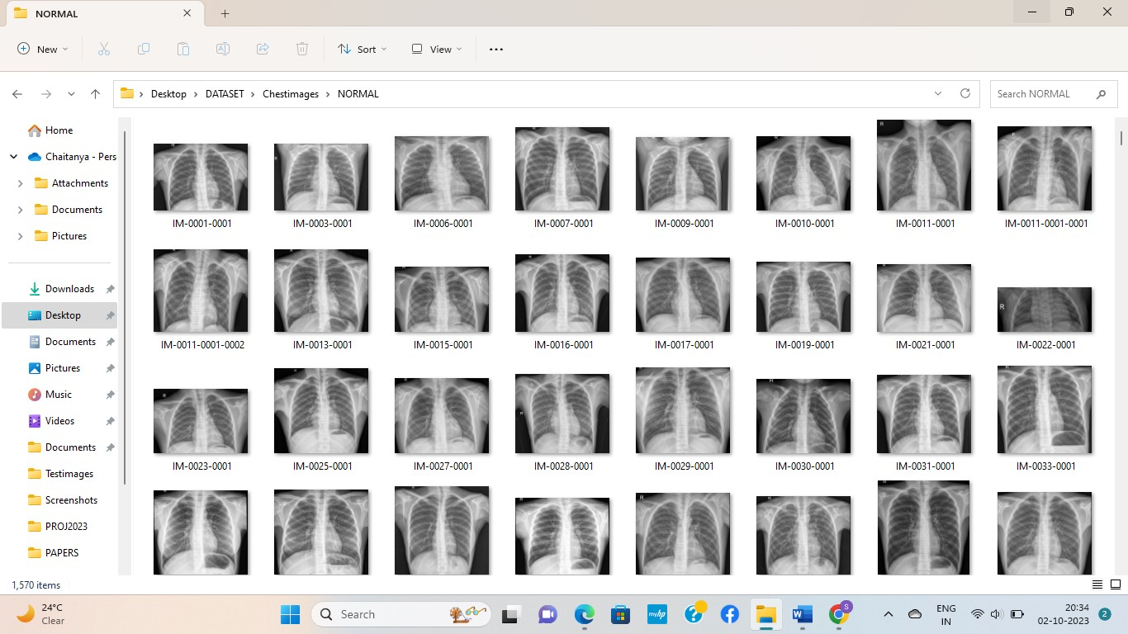The dataset is divided into two classes, Pneumonic and Normal. There are 5,830 JPEG Chest x-ray images and two categories (Pneumonia/Normal). Among them 4260 pneumonic images and 1570 normal and I divide dataset 80:20 percent for training and testing.

Figure 3.4: Normal Chest x-ray images

Figure 3.4 consists of Normal chest x-ray images which displays healthy lung structures with clear and symmetrical lung fields. The trachea and main bronchi should be unobstructed. The heart and mediastinum appear normal, while ribs and bony structures are intact.

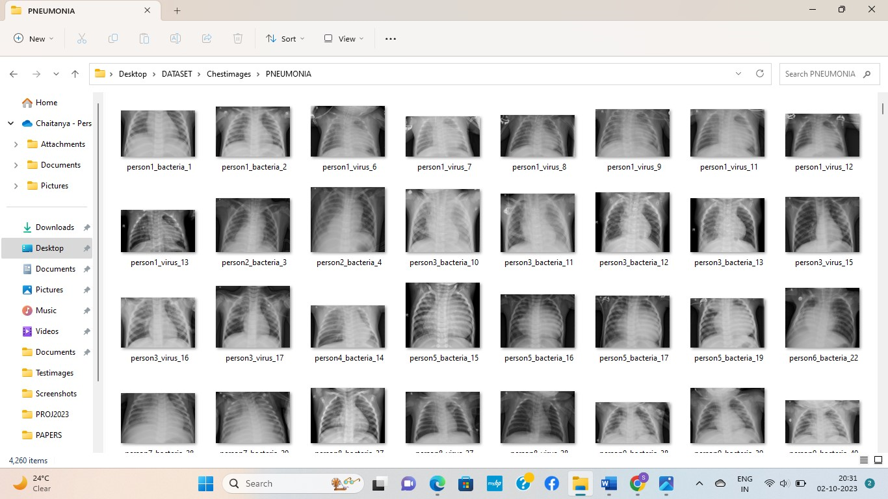Figure 3.5: Pneumonic images

Figure 3.5 consists of pneumonic chest x-ray images which displays lungs with cloudy or hazy patches, indicating areas filled with fluid and inflammation. These patches appear whiter than normal lung tissue. Pneumonia can affect one or both lungs, and the cloudy areas may be spread throughout or concentrated in specific regions. The lung borders may not be as clear as in a normal X-ray due to the infection. Additional signs, like fluid around the lungs or changes in the heart area, might also be visible.

**3.2 Data Preprocessing**

Data preprocessing is a crucial step in preparing raw data for analysis or training machine learning models. It involves transforming and cleaning the data to ensure that it is in a suitable format for further analysis or modelling. Effective preprocessing ensures data is suitable for analysis or modelling, improving model performance and insights. Steps may vary based on data, domain, and analysis objectives. **Prepare the input images by performing preprocessing steps such as resizing, normalization, and augmentation**. They were resized to a compatible size for better computation. Two arrays, ‘data’ and ‘target’ are created where ‘data’ stores pre-processed (resized image) data and ‘target’ stores the label which is again stored back in the file we use the function ‘resize’ of OpenCV, and uploading the images

* **Read Image**

By choosing an image processing library which is compatible with our programming language. keras.model library is used to load images from specified file locations. Then representing images in arrays, with each element representing the value of a pixel. Prepare images for analysis by resizing, changing the color space, or doing other appropriate preparatory actions. Use the library to display images as an option to aid in visualization and verification procedures.

* **Resizing And Grayscale**

The objective is to resize images to a consistent size, which is a common preprocessing step in image analysis. This phase is critical for ensuring uniformity and consistency in the dataset, which is required for efficiently training machine learning models. This is achieved using the OpenCV library (cv) to manipulate the images. The Dataset we used contain images of varying sizes, that’s why we use resize method to transform them all to the same size, which is useful for future analysis or modelling. The images are then scaled to the necessary dimensions of 128x128 pixels.

The chosen size is 128x128 pixels which is a reasonable trade-off between computational efficiency and retaining essential image features. The dataset is initialized to store the resized images along with their corresponding labels. The code iterates through different image categories, each contained within its respective folder. For each image in a category, it is loaded using OpenCV and converted to grayscale. Grayscale conversion simplifies the image's representation and is often adequate for various analyses. The resized images are then appended to the dataset, along with their matching labels extracted from the categories.

To account for any potential problems throughout the image processing processes, the code provides exception handling via a try-except block. This ensures that the function continues to execute even if an error occurs during image processing, with any observed faults reported for reference and debugging. Overall, this code segment demonstrates an efficient approach to resizing images and organizing them into a dataset, a fundamental preprocessing step in preparing image data for machine learning projects.

**3.3 Splitting Data**

Splitting the data in a machine learning project is a fundamental step to effectively train and evaluate a model. The train_test_split function partitions the dataset into training and testing subsets. The objective is to divide the dataset into distinct subsets, to facilitate the training and validation of the model's performance. The training set is a portion of the dataset used to train the machine learning model. The model learns the patterns and features from this set to make predictions. The testing set is kept separate and not used during the training phase. It is used to evaluate the model's performance after it has been trained. The model predicts outcomes for this set, and the predictions are compared with the actual target values.

Data splitting is usually done randomly to ensure an unbiased representation of the entire dataset in both the training and testing sets. Randomness helps in preventing any inadvertent bias that may arise from a specific ordering of data. The data variable contains the features, while target holds the corresponding labels. Data splitting is required to determine how well a machine learning model will function on previously unseen, new data. It aids in determining the model's capacity to generalize and generate accurate predictions beyond the data on which it was trained.

In this project, I divide data into 80:20 of training and testing subsets respectively. That is test_size = 0.2 specifies that 20% of the data will be allocated to the testing set, leaving 80% for training. This is a common split ratio, but it can be adjusted based on the dataset size and project requirements. Here we use four variables, train_data and test_data These variables store the training and testing sets of features respectively, resulting from the split operation. And train_target and test_target hold the corresponding labels (target values) for the training and testing sets, reflecting the labels associated with the images.

* **Training Set**

The training set is a vital segment of the dataset used to train a machine learning model. It contains a majority of the samples and serves as the basis for teaching the model by exposing it to a diverse range of input features and corresponding target values. The model learns patterns, relationships, and features from this data, adjusting its parameters iteratively through algorithms to optimize predictions. The training set includes both input features (images) and target values (desired outputs). Its representative and diverse nature ensures the model learns robustly, striking a balance between simplicity and complexity. The trained model is evaluated using a separate validation set, and the training process is often iterative, refining the model until satisfactory performance is achieved. The training set is fundamental in the machine learning workflow, contributing to the development of accurate and reliable models.

* **Testing Set**

The testing set, distinct from the training set, is critical in determining a machine learning model's capacity to generate correct predictions on new, previously unknown data. It acts as an unbiased testing ground, assisting in the verification of the model's performance, robustness, and ability to generalize beyond the data on which it was trained. The testing set aids in identifying overfitting and validating the model's fitness for real-world applications by comparing the model's predictions with actual target values.

**3.4 Convolution Neural Network**

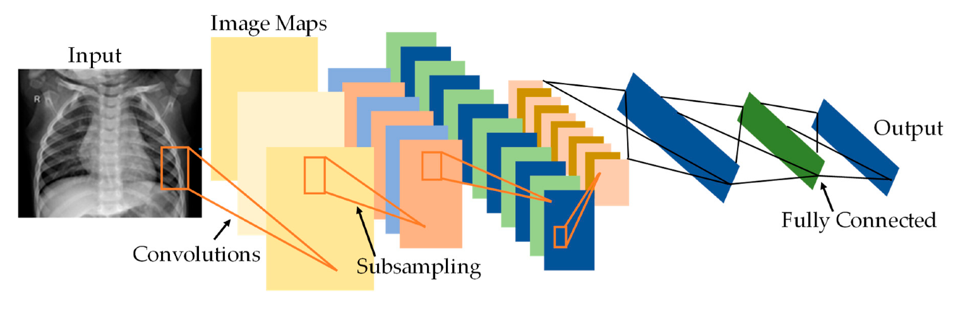Convolution neural networks (figure 3.6) trained on normal and positive Chest X-ray images for pneumonia to accurately determine whether or not. In this attempt to solve the problem, here tried to detect whether a chest x-ray conclude that a person is ill with pneumonia or normal patients and do so by searching for any cloudy pattern in the X-ray.

Figure 3.6: CNN for pneumonia detection

In this project, three convolution layers are used for processing, The first initial layer processes input chest X-ray images through 32 filters of size 3x3, detecting fundamental patterns. It sets the foundation for feature extraction in the model. The second layer adds another 32 filters of size 3x3, further enhancing feature representation. Contributes to capturing diverse patterns and details from the X-ray images. Third layer build upon the previous layers, this introduces 64 filters of size 3x3, deepening feature learning and enhances the model's ability to detect complex and higher-level features in the chest X-ray images. In summary, these Conv2D layers incrementally learn patterns of increasing complexity, crucial for accurate classification of chest X-ray images into "NORMAL" and "PNEUMONIA" categories. The variety of filters and their sizes enrich the feature extraction process, ultimately enhancing the model's understanding of the input data. Here ReLU (Rectified Linear Unit) Activation function is used in input layer.

* **Max Pooling**

Max Pooling divides the input image into non-overlapping rectangular regions. Below figure 3.7 explains, for each region, it keeps only the maximum value from that region and discards the rest. Max pooling present after every convolution layer because, Max Pooling reduces the spatial dimensions (width and height) of the feature maps, making subsequent layers computationally more efficient and easier to manage. It takes parameter pool_size (2,2) which defines a 2x2 frame over which the max pooling operation is performed. Stride and Padding remains same as in convolution layer.

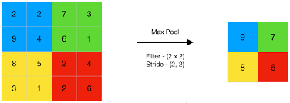

Figure 3.7: Max pooling

For this project, fully connected layer (dense layer) with 128 units and ReLU activation, enhancing feature learning. And a dropout layer with a 50% dropout rate, reducing overfitting by randomly deactivating neurons during training. Another dense layer with 2 units and Softmax activation, facilitating classification in binary scenarios by assigning class probabilities. Here Softmax activation function is used in output layer because of categorical data. For each element in the input vector, Softmax exponentiates the element and divides it by the sum of exponentiated values for all elements, thus ensuring the output is a valid probability distribution.

The model is trained using the model.fit method in my code. The input training data is stored in train_data, and the target labels are stored in train_target. Training takes place across a set number of epochs (in my project it is 8). An epoch is one complete trip through the training dataset. The model is trained using the supplied training data, with the goal of minimizing the defined loss function using the optimizer of choice. The model's weights are changed throughout training, and the loss and any specified metrics are computed. Here Binary Classification takes place, that means provided input chest x-ray images categorized into two classes pneumonia and non-pneumonia and the output will lead to either pneumonic or not.

Compiling a model involves configuring the model for the training process by specifying essential aspects like the optimizer, loss function, and metrics.

* The optimizer determines how the model's weights are updated during training to minimize the defined loss function. The optimizer I selected is Adam. It is a popular optimization algorithm that adapts the learning rates for each parameter, making it efficient and effective for training neural networks.
* The loss function is a measure of how well the model's predictions match the true targets during training. It's the quantity that the optimizer aims to minimize. The chosen loss function is categorical cross-entropy. This loss is suitable for multi-class classification problems, where each input sample belongs to a single

Finally model with high validation accuracy, recall, and F1 scores. Recall created which is frequently preferred over other performance assessing factors in medical imaging scenarios because it provides a measure of false negatives in the data. The number of false negatives in the outcome is extremely important in figuring out how well models work in the actual world. If a model achieves high accuracy but low recall values, it is termed as underperforming, ineffective, and even risky. Since a greater false-negative value indicates that there are more cases where the model incorrectly predicts that a patient is healthy when they are not. It may risk the patient’s life, to prevent this, the focus would be on models recall values, decent accuracies and F1 scores.

**3.5 Data Visualization**

Data visualization is a process of representing data graphically to provide insights, patterns, and trends that might not be apparent from raw data alone. It's a crucial aspect of data analysis and interpretation, helping to convey complex information in an easily understandable and interpretable manner.

Here Data Visualization is used for Confusion matrix, heatmap, bar chart and graphs to visualize the model's performance on the test dataset. These visualizations provide insights into project concepts. Accuracy and Loss, being a critical metrics, might have been visually represented graphical representations. This helps in understanding how the model's accuracy and loss changes over the course of training.

**3.6 Classification Output**

In this project, classification output refers to the model's predictions for chest X-ray images, specifically categorizing them into two classes: "Normal" and "Pneumonia". The trained neural network, based on its learned parameters and features, predicts the class label for each chest x-ray image provided as input. If we provide an image for model, model predict it as pneumonic or normal based on its performance.

* **Binary Classification:**

The model performs binary classification, classifying each Chest X-ray image into one of two categories: "Normal" or "Pneumonia"

**4.RESULTS AND DISCUSSION**

In this project, I used a chest x-ray dataset to develop a Convolution neural network model for distinguishing between normal and pneumonia-affected X-ray images. The dataset was preprocessed, including resizing the images to a standard size and converting them to grayscale. And I divided the dataset into training and testing sets, crucial for assessing the model's performance. The neural network architecture consisted of convolutional layers for feature extraction, pooling layers for downsampling, and dense layers for classification. During training, the model learned to differentiate between normal and pneumonia-affected X-ray images. The model's performance was evaluated using appropriate metrics, such as accuracy, which indicated how well the model generalized to unseen data. The model evaluation function provides important metrics that evaluate the performance of my trained model on a test dataset. These metrics give insights into how well the model generalizes to unseen data.

I’m, getting 94% of accuracy for my model. It signifies that it accurately predicted the chest X-ray images classifications nearly 94% of the time during the evaluation. In simpler terms, out of every 100 chest X-ray images, the model correctly identified if they were normal or pneumonia-affected in approximately 94 cases. Now, the results demonstrated the effectiveness of the model in accurately classifying chest X-ray images, providing a valuable tool for diagnosing pneumonia based on X-ray data. The successful implementation of this model showcases its potential for real-world applications in healthcare and medical diagnosis.

* **Confusion Matrix**

A confusion matrix is a table often used in classification tasks to evaluate the performance of the model. It provides a comprehensive summary of the model's predictions compared to the true target values. The matrix has rows and columns representing the predicted and true classes, respectively. Confusion matrix consider the target and predictions as parameters and provide visual representation.

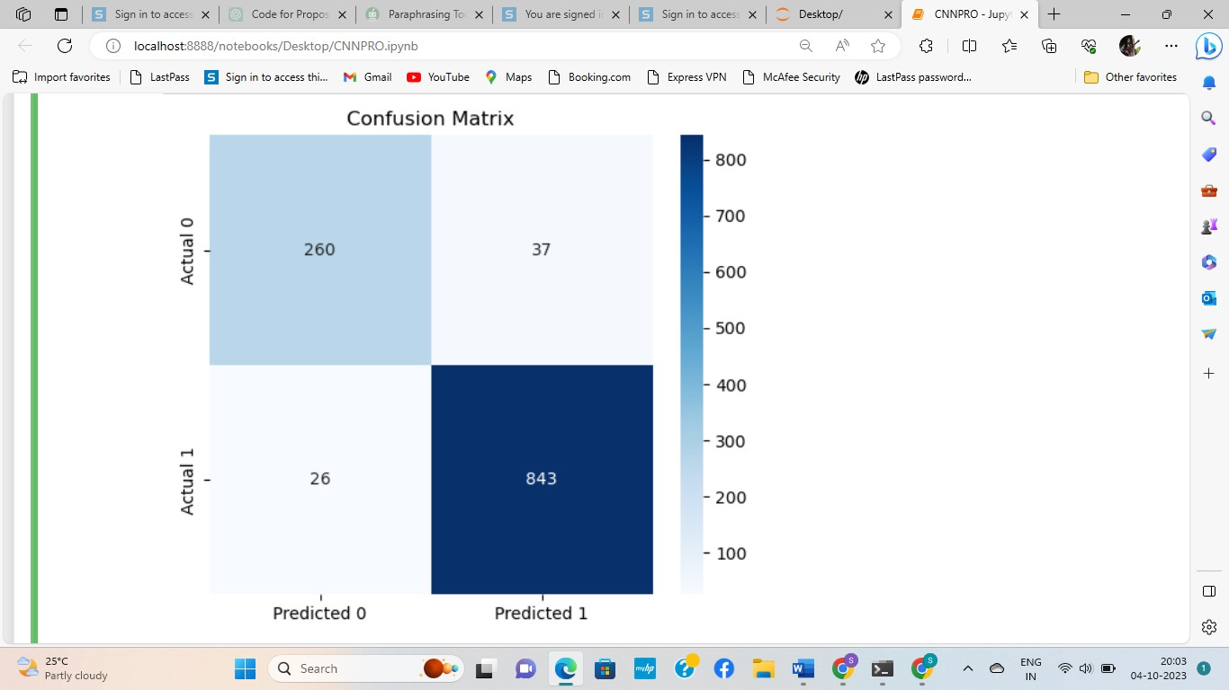

Figure 4.1: Confusion matrix

Figure 4.1 describes confusion matrix of this project which explains, Predicted as Normal (0) and actually are Normal (0) is called True Positives. Predicted as Pneumonic (1) and actually are Pneumonic (1) called True negatives. Predicted as Normal (0) but actually are Pneumonic (1) called False positives. Predicted as Pneumonic (1) but actually are Normal (0) are called False negatives.

* **Classification Report**

A classification report is a summary of the evaluation metrics for a classification model, providing detailed the model's performance for each class. Precision is defined as the percentage of true positive predictions out of all anticipated positives (true positive + false positive). The fraction of true positive predictions out of total actual positives (true positive + false negative) is referred to as recall. The F1 score is the harmonic mean of precision and recall, which provides a balance of the two metrics. The term support refers to the number of instances of each class in a dataset. It gives information on the distribution of instances across classes. Below table 4.1 describe classification report of this project.

|  |  |  |  |  |
| --- | --- | --- | --- | --- |
|  | precision | recall | f1-score | support |
| NORMAL | 0.94 | 0.85 | 0.89 | 323 |
| PNEUMONIA | 0.94 | 0.98 | 0.96 | 843 |
| accuracy |  |  | 0.94 | 1166 |
| macro avg | 0.94 | 0.91 | 0.92 | 1166 |
| weighted avg | 0.94 | 0.94 | 0.94 | 1166 |

Table 4.1: Classification report

The better understand of loss and accuracy is done by plotting graph for illustrating the model's training loss over epochs, and model’s training accuracy over epochs, giving a visual representation of how the loss and accuracy diminishes as the model iteratively learns during training.

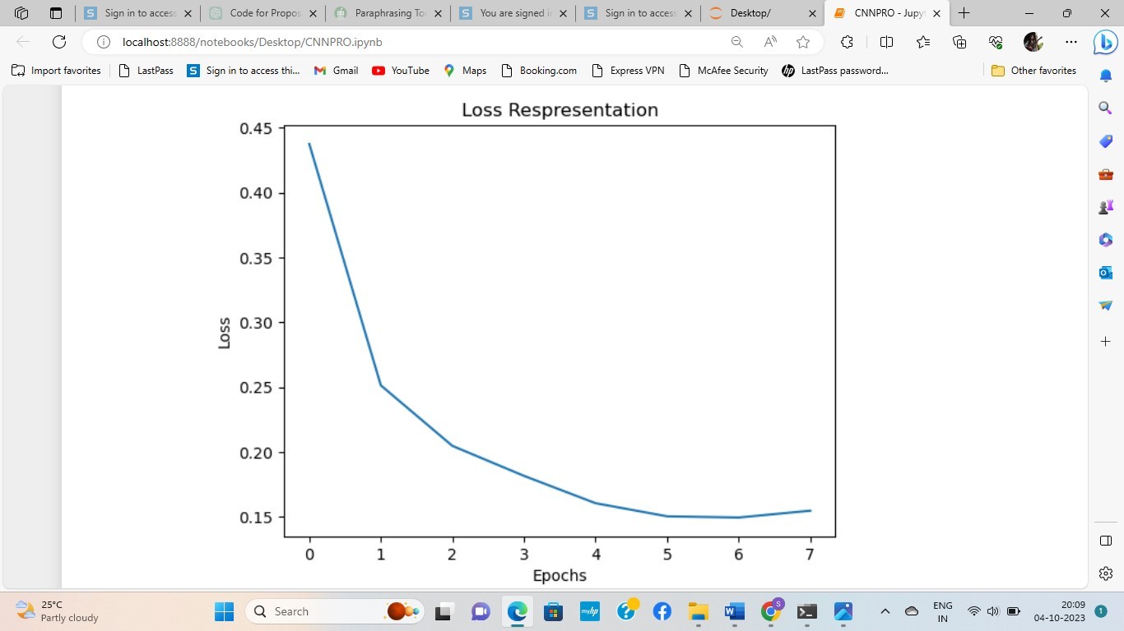

Figure 4.2: Loss representation

Figure 4.2 illustrate the graph for Loss representation of project, for loss representation graph, the x-axis represents epochs, and the y-axis represents the loss. The "loss" in this project, refers to a numerical measure that quantifies the difference between predicted values (output of the model) and actual ground truth values for a given set of data.

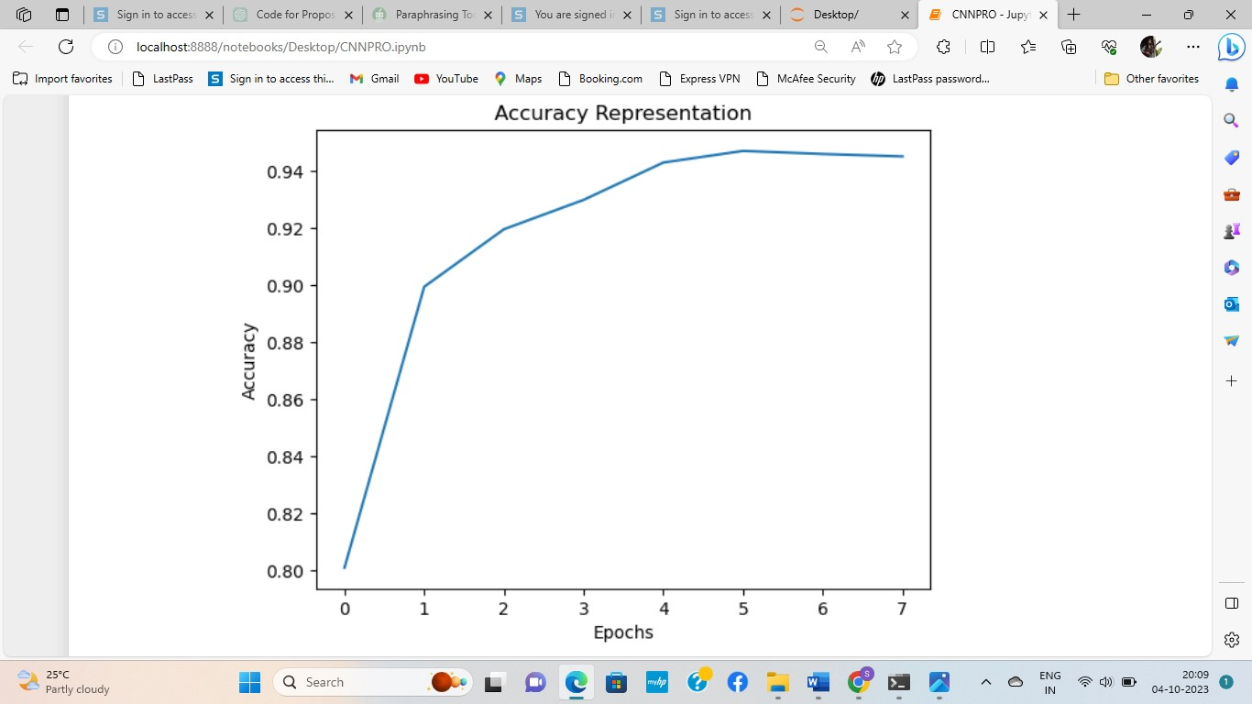

Figure 4.3: Accuracy representation

Figure 4.3 illustrate the graph for Accuracy representation of project, For Accuracy representation graph, the x-axis represents epochs, and the y-axis represents the accuracy. "Accuracy" in the context of this project, represents the proportion of correctly classified instances (or samples) out of the total instances in the dataset. It is a fundamental metric to evaluate the performance of a classification model.

* **Gradio**

Gradio is an open-source Python library that simplifies the deployment and sharing of machine learning models. It allows us to create interfaces for our models, making them accessible and usable for non-technical users. With Gradio, we can create interactive and customizable interfaces to demonstrate our model's capabilities and obtain predictions in real-time.

Here Gradio is used for this project for an intuitive and user-friendly interface to interact with model. It enables them to upload chest X-ray images and obtain predictions instantly. The Gradio interface allows users to witness live predictions from the model by uploading Chest X-ray images. It provides real-time insights into the model's performance. Gradio enhances the user experience by simplifying the process of inputting new data for predictions. Users can easily upload the Chest X-ray image and immediately see the model's classification output.

**4.1 Snapshots**

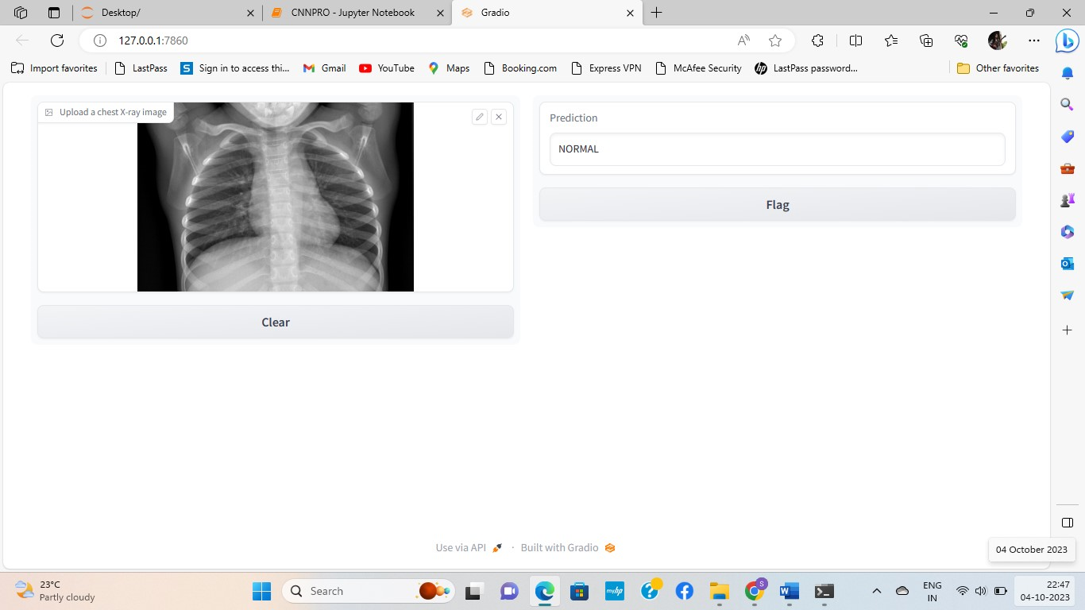Here are some snapshots showcasing the Gradio interface in the project

Figure 4.4: Detection of Normal x-ray

Figure 4.4 is a screenshot of output gradio interface. Here the Gradio interface takes input (chest x-ray image) and produces a normal as the output.

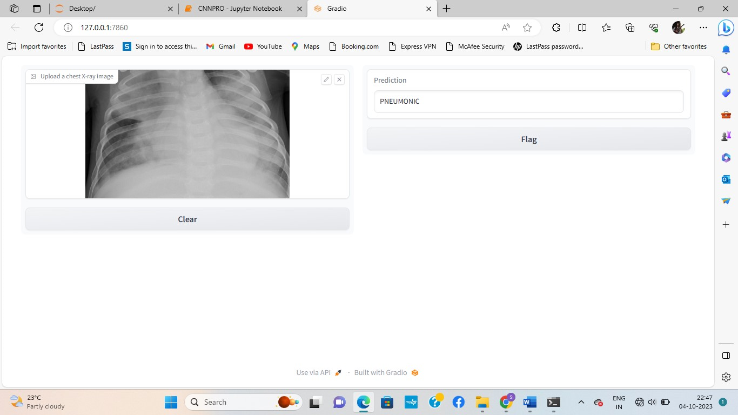

Figure 4.5: Detection of Pneumonic x-ray

Figure 4.5 is a screenshot of output gradio interface. Here the Gradio interface takes input (chest x-ray image) and produces a pneumonic as the output.

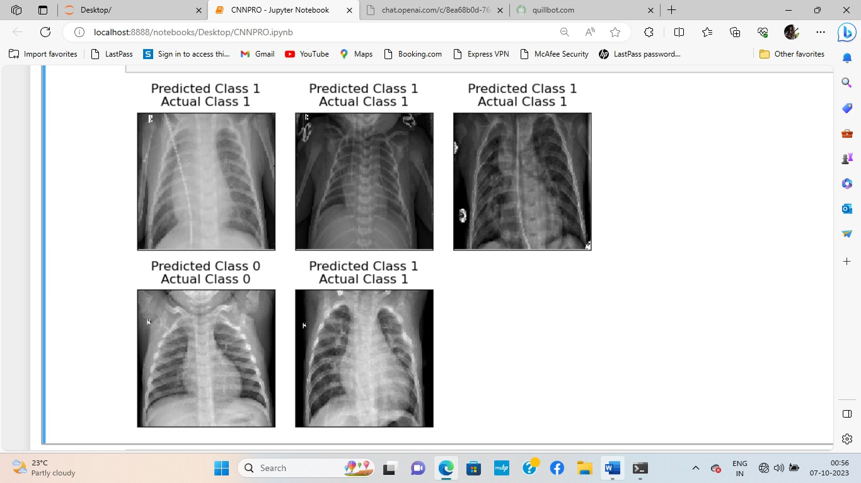

Figure 4.6: Correct Predicted images

Above figure 4.6 consists of images and its actual class and correct predicted class.

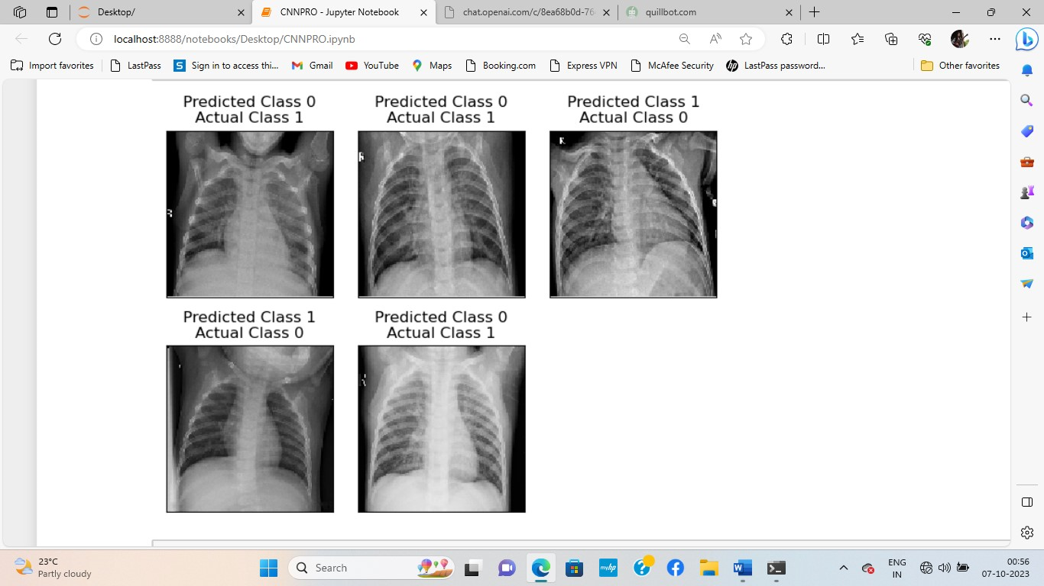

Figure 4.7: Wrong Predicted images

Above figure 4.7 consists of images and its actual class and wrong predicted class.

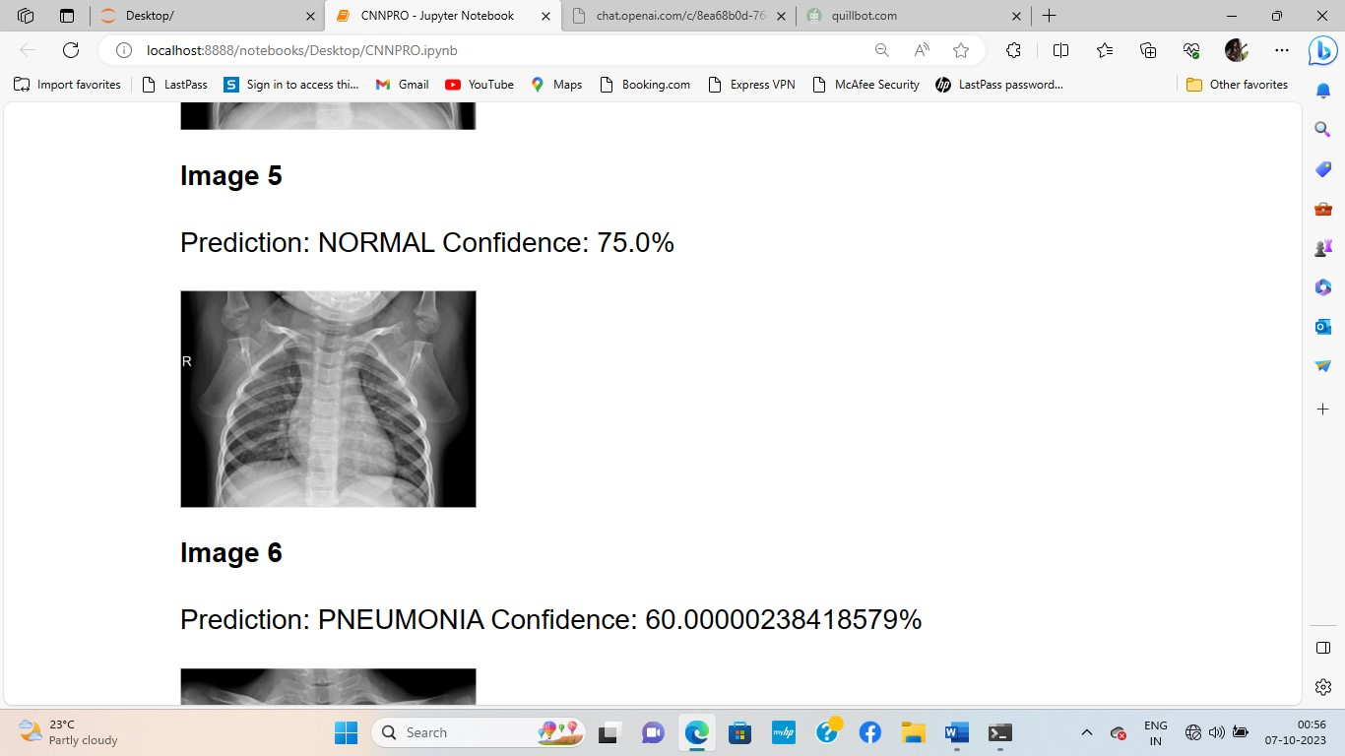

Figure 4.8: Confidence percentage of Normal image

Figure 4.8 illustrates a description containing the image, prediction, and confidence details. It shows it is a normal image and the confidence level is 75%.

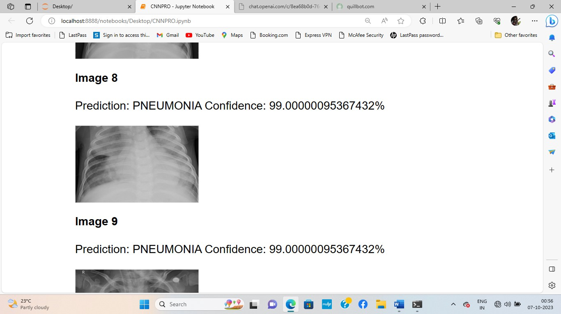

Figure 4.9: Confidence percentage of Pneumonic image

Figure 4.9 illustrates a description containing the image, prediction, and confidence details. It shows it is a normal image and the confidence level is 75%.

**5.CONCLUSION**

In this project, successfully developed a robust and interpretable deep learning model for the detection of pneumonia from chest X-ray images. Using a selected dataset of chest X-ray images, I preprocessed the data, created a Convolutional Neural Network (CNN), and achieved impressive accuracy. The model achieved a noteworthy accuracy of 94%, highlighting its potential for practical application. The Gradio interface enabled users to interact with the model in a smooth and engaging manner, making it more accessible to more people.

* **Future Work**

Future work could focus on fine-tuning the model, exploring transfer learning, and integrating additional features for improved performance. Furthermore, user feedback and ongoing model refinement will be important in maintaining the model's dependability and use in real-world healthcare applications.

We can also add other disease detection with this project, to detect multiple diseases, convert the model into a multi-class classification model. The model will then classify X-ray images into normal, pneumonia, and the additional disease(s).

In the future studies, we can focus on developing a hybrid model capable of simultaneously detecting both pneumonia and COVID-19 in chest X-ray images. This comprehensive approach aids in providing a more holistic diagnostic assistance tool for healthcare professionals.

**References**

[1] Tatiana Gabruseva, Dmytro Poplavskiy, Alexandr Kalinin University of Michigan Ann Arbor, MI 48109 USA, and Shenzhen Research Institute of Big Data, Shenzhen 518172, Guangdong, China, “Deep Learning for Automatic Pneumonia Detection” on 2020

[2] Dimpy Varshni, Kartik Thakral, Lucky Agarwa, Rahul Nijhawan, Ankush Mittal, “Pneumonia Detection Using CNN based Feature Extraction”, College of Engineering Roorkee Roorkee, India on 2019

[3] Marwa M. Eid and Yasser H. Elawady, “Efficient Pneumonia Detection for Chest Radiography Using ResNet-Based SVM”, on 1 January 2021.

[4] Pranav Rajpurkar, Jeremy Irvin, Kaylie Zhu, Brandon Yang, Hershel Mehta, Tony Duan, Daisy Ding, Aarti Bagul, Robyn L. Ball, Curtis Langlotz, Katie Shpanskaya, Matthew P. Lungren, Andrew Y. Ng, “CheXNet: Radiologist-Level Pneumonia Detection on Chest X-Rays with Deep Learning”, dec 2017

[5] Alaa M. A. Barhoom and Prof. Dr. Samy S. Abu Naser, “Diagnosis of Pneumonia Using Deep Learning”, Deprtment of Information Technology, Faculty of Engineering and Information Technology, Al-Azhar University, Gaza, Palestine, Feb 2022

[6] Ebru Erdem, Tolga Aydın, “Detection of Pneumonia with a Novel CNN-based Approach” on 05 February 2021 Department of Computer Engineering, 25240, Erzurum, Turkey.

[7] Sumair Aziz, Muhammad Umar Khan, Maheen Shakeel, Zohaib Mushtaq, Aleena Zaman Khan, “An Automated System Towards Diagnosis of Pneumonia using Pulmonary Auscultations”, 2019 13th International Conference on Mathematics, Actuarial Science, Computer Science and Statistics (MACS).

[8] A Sharma, M Negi, A Goyal, R Jain and P Nagrath Bharati Vidhyapeeth’s College of Engineering, New Delhi, “Detection of Pneumonia using ML & DL in Python” on 2021

[9] Rabia Emhamed Al Mamlook, Shengfeng Chen and Hanin Fawzi Bziz, “Investigation of the performance of Machine Learning Classifiers for Pneumonia Detection in Chest X-ray Images”, July 2020.

[10] A.Beena Godbin and S.Graceline Jasmine, “Analysis of pneumonia detection systems using deep learning-based approach”, Vellore Institute of Technology Chennai.on 2022

[11] Veeranjaneyulu Naralasetti, Reshmi Khadherbhi Shaik, Gayatri Katepalli, Jyostna Devi Bodapati, “Deep Learning Models for Pneumonia Identification and Classification Based on X-Ray Images”, Department of IT, VFSTR Deemed to be University, Vadlamudi 522213, Guntur, India on 10 April 2021.

[12] Wachiraphong Ratiphaphongthon, Wanida Panup, and Rabian Wangkeeree, “An Improved Technique for Pneumonia Infected Patients Image Recognition Based on Combination Algorithm of Smooth Generalized Pinball SVM and Variational Autoencoders”, Department of Mathematics, University of York, YO10 5DD Heslington, U.K. on 2021

[13] Abhir Bhandarya, G. Ananth Prabhub, V. Rajinikanthc, K. Palani Thanarajc, Suresh Chandra Satapathyd, David E. Robbinse, Charles Shaskyf, Yu-Dong Zhangg, João Manuel R. S. Tavaresh, N. Sri Madhava Rajac, “Deep-Learning Framework to Detect Lung Abnormality – A study with Chest X-Ray and Lung CT Scan Images”, Department of Information Science Engineering, NMAM Institute of Technology, Nitte, Karnataka 574110, India 2019.

[14] Harshvardhan gm, Mahendra Kumar Gourisaria, Siddharth Swarup Rautaray, Manjusha Pandey, “Pneumonia detection using CNN through chest x-ray”, School of Computer Engineering, KIIT Deemed to be University, Bhubaneswar, Odisha, India, on February 2021.

[15] Narayana Darapaneni, Ashish Ranjan, Dany Bright, Devendra Trivedi, Ketul Kumar, Vivek Kumar, and Anwesh Reddy Paduri, “Pneumonia Detection in Chest X-Rays using Neural Networks”, Northwestern University/Great Learning, US 2-7 Great Learning, Bangalore, India.

[16] V. Sirish Kaushik, Anand Nayyar, Gaurav Kataria and Rachna Jain, “Pneumonia Detection Using Convolutional Neural Networks (CNNs)” by Bharati Vidyapeeth’s College of Engineering, New Delhi, Delhi, India, on April 2020.

[17] Sukhendra Singh, Manoj Kumar, Abhay Kumar, Birendra KumarVerma & S. Shitharth, “Pneumonia detection with QCSA network on chest X‑ray”.

[18] Muazzez Buket DARICI, Zumray DOKUR, Tamer OLMEZ, “Pneumonia Detection and Classification Using Deep Learning on Chest X-Ray Images” at Istanbul Technical University, Department of Electronics and Communication Engineering., Istanbul, TURKEY, on 23/11/2020

[19] Issac Neha Margret, Chalumuru Suresh, B.V. Kiranmayee, “Classification of X-ray Images for Pulmonary Diseases Using Deep Learning Techniques”,2022

[20] Tawsifur Rahman, Muhammad E. H. Chowdhury, Amith Khandakar, Khandaker R. Islam, Khandaker F. Islam, Zaid B. Mahbub, Muhammad A. Kadir and Saad Kashem, “Transfer Learning with Deep Convolutional Neural Network (CNN) for Pneumonia Detection Using Chest X-ray”, Department of Biomedical Physics & Technology, University of Dhaka, Dhaka 1000, Bangladesh;6th may 2020

[21] Deniz Yagmur Urey, Can Jozef Saul, and Can Doruk Taktakoglu, Robert College of Istanbul, Istanbul, Turkey 2Koc University Artificial Intelligence Laboratory, Istanbul, Turkey. “Early Diagnosis of Pneumonia with Deep Learning”, Apr 2019

[22] So-Mi Cha, Seung-Seok Lee and Bonggyun Ko, “Attention-Based Transfer Learning for Efficient Pneumonia Detection in Chest X-ray Images”, Department of Mathematics and Statistics, Chonnam National University, 77, Yongbong-ro, Buk-gu, Gwangju 61186,on 2021

[23] G. Jignesh Chowdarya, G. Suganyab, M. Premalathac, S. Ganapathyd, “Impact Of Machine Learning Models In Pneumonia Diagnosis With Features Extracted From Chest X-Rays Using VGG16”, School of Computer Science and Engineering, Vellore Institute of Technology Chennai, Chennai, Tamil Nadu, India. On 5th April 2021